A Speedy Slide
You have been familiar with playgrounds and slides since you were a small child. The force of gravity pulls you down a slide. The force of friction slows you down. In the first part of this experiment, you will use a Motion Detector to determine your speed or velocity going down a playground slide. In the second part, you will experiment with different ways to increase your speed going down the slide.
OBJECTIVES
In this experiment, you will
- Use a Motion Detector to determine your speed going down a slide.
- Experiment with ways to increase your speed going down the slide.
- Explain your results.
MATERIALS
LabQuest | Motion Detector
LabQuest App | playground slide

Figure 1
PROCEDURE
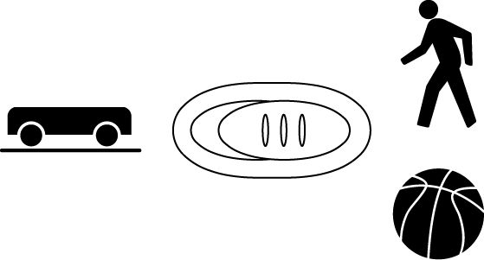
Part I Sliding Speed
1. If your Motion Detector has a switch, set it to Normal. Connect the Motion Detector to DIG 1 of LabQuest and choose New from the File menu. If you have an older sensor that does not auto-ID, manually set up the sensor.
2. On the Sensor screen, tap Rate. Change the data-collection rate to 5 samples/second and the data-collection length to 5 seconds.
3. Take your preliminary data-collection positions.
- One member of the group should first go up the slide steps and sit at the top of the slide.
- A second person, while holding the Motion Detector, should go high enough on the slide steps to hold the Motion Detector behind the person who will slide.
- The third person should stand on the ground next to the slide, while holding the interface.
4. Take your final data-collection positions.
- The slider, while holding on, should move forward enough to allow a 50 cm distance between his or her back and the Motion Detector.
- The person holding the Motion Detector should hold the Motion Detector steady and aim it at the slider’s backside.
- The person holding the interface should move to a comfortable position that does not cause a pull on the Motion Detector cable.
5. Collect data.
- Start data collection.
- The slider should begin to slide as soon as data collection begins.
- When data collection is done for this trial, the person with the Motion Detector should come down to the ground. Caution: No student should attempt to pass another person while he or she is on the steps.
6. Determine the slider’s speed.
- After data collection stops, examine the velocity vs. time graph. To examine the data pairs on the displayed graph, tap any data point. As you tap each data point, the velocity and time values of each data point are displayed to the right of the graph.
- The highest point on the graph corresponds to the highest velocity of the slider. Record this highest velocity in the data table. Round to the nearest 0.01 m/s.
7. Repeat Steps 3–6 two more times.
Part II A Speedier Slide
8. Design a plan to increase the slider’s speed.
- Try out some ideas for increasing the slider’s speed. You may not coat the slide with anything that must be washed off.
- Decide on a plan to best increase the slider’s speed.
- Describe your plan in the Speedier Slide Plan section below.
9. Test your plan using Steps 3–7.
SPEEDIER SLIDE PLAN

DATA
 | Speed (m/sec)
 | Trial 1 | Trial 2 | Trial 3 | Average
Part I
Part II

PROCESSING THE DATA
1. Calculate the average speed for your three trials in Part I. Record the average in the space provided in the data table. Calculate and record the average speed for Part II.

2. Subtract your Part I average speed from your Part II average speed to determine how much your team improved its speed.

3. What methods did other groups use to improve their speeds?

4. Which of the methods worked best? Explain why it worked best.

5. If you could increase the height of the slide, how would the slider’s speed be affected?

6. If a stone was dropped from the top of the slide at the same time similar stone was rolled down the slide, which stone would reach the ground first? Explain.

7. What is the purpose of the level portion at the bottom of many slides?

EXTENSIONS
1. Design and carry out a plan to measure your speed or velocity on a different piece of playground equipment.
2. Have a contest to see who in your class or group can obtain the greatest speed going down a slide.

