Falling Objects
Galileo tried to prove that all falling objects accelerate downward at the same rate. Falling objects do accelerate downward at the same rate in a vacuum. Air resistance, however, can cause objects to fall at different rates in air. Air resistance enables a skydiver’s parachute to slow his or her fall. Because of air resistance, falling objects can reach a maximum velocity or terminal velocity. In this experiment, you will study the velocities of two different falling objects.
OBJECTIVES
In this experiment, you will
- Use a Motion Detector to measure distance and velocity.
- Produce position vs. time and velocity vs. time graphs.
- Analyze and explain the results.
MATERIALS
LabQuest | right-angle clamp
LabQuest App | basket coffee filter
Motion Detector | 3 books
ring stand | meter stick
metal rod

Figure 1

PROCEDURE
Part A Falling Coffee Filter
1. Set up the apparatus as shown in Figure 1.
- Place two books on the base of a ring stand to keep it from falling.
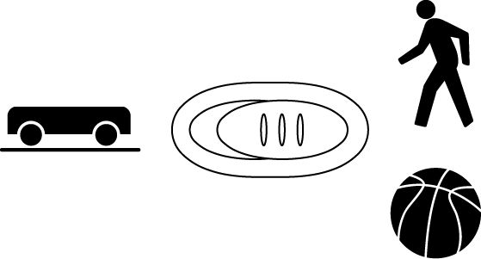
- Use a right-angle clamp to fasten a metal rod to the ring stand.
- If your Motion Detector has a switch, set it to Normal.
- Fasten a Motion Detector under one end of the rod. The Motion Detector should face down and be parallel to the floor.
- Move the right-angle clamp, rod, and Motion Detector to the top of the ring stand.
- Use a piece of tape to mark a spot on the ring stand that is 50 cm from the right-angle clamp.
- Place the ring stand, with the Motion Detector attached, at the edge of your lab table. The Motion Detector must extend 50 cm beyond the table edge.
2. Connect the Motion Detector to DIG 1 of LabQuest and choose New from the File menu. If you have an older sensor that does not auto-ID, manually set up the sensor.
3. On the Sensor screen, tap Rate. Change the data-collection rate to 10 samples/second and the data-collection length to 5 seconds.
4. Collect data for a falling coffee filter.
- Hold a basket coffee filter with the open side facing up at a position 0.5 m from (at the 0.5 m mark on the ring stand) and directly below the Motion Detector.
- Start data collection.
- After data collection begins, allow the coffee filter to drop straight down.
5. Examine the position vs. time graph for the falling coffee filter.
- After data collection stops, examine the position vs. time graph. To examine the data pairs on the displayed graph, tap any data point. As you tap each data point, the position and time values of each data point are displayed to the right of the graph. Examine the graph and discuss it with your lab partners. If it is satisfactory, sketch the graph in the space provided in the Data section. Label the important features of your graph. If necessary, repeat the drop.
- Position the examine line at the filter’s drop point. Record the time (in seconds) and position (in meters) in the data table (round to the nearest 0.01).
- Position the cursor at the filter’s landing point. Record the time (in seconds) and position (in meters) when the filter landed in the data table (to the nearest 0.01).
6. Examine the velocity vs. time graph for the falling coffee filter.
- Examine the velocity vs. time graph and discuss it with your lab partners. Sketch the graph in the space provided in the Data section. Label the important features of your graph.
- Position the cursor at the highest point on the velocity vs. time graph. Record this highest velocity (in m/s) in the data table (round to the nearest 0.01 m/s).
Part B Falling Book
7. Repeat Steps 4–6 using a book.

DATA
Falling Coffee Filter

Falling Book

 | Position (Y) | Time (X) | Position (Y) | Time (X)
Drop point | m | s | m | s
Landing point | m | s | m | s
Highest velocity | m/s |  | m/s
PROCESSING THE DATA
1. Calculate the distance fallen (in m) for each object. (Subtract the drop-point position from the landing-point position.)

2. How do the distances compare? Why do the distances compare this way?

3. Calculate the falling time (in s) for each object. (Subtract the drop-point time from the landing-point time.)

4. How do the falling times compare?

5. Which object fell faster? Why?

6. How are the two position vs. time graphs different? Explain the differences.

7. How are the two velocity vs. time graphs different? Explain the differences.
8. Compare the highest velocities of your two objects. Which object was falling faster when it landed? Why was it falling faster?

9. For which object is air resistance more important? Why does air resistance affect this object more than the other object?

10. Which of your velocity vs. time graphs would be more like the velocity vs. time graph of an object falling in a vacuum? Why?
11.
On the graph above, sketch a velocity vs. time curve for an object that is released at 0.5 s, falls with increasing velocity until 1.5 s, falls at constant velocity from 1.5 s to 3.0 s, and lands at 3.0 s. An object that falls at constant velocity is said to have reached terminal velocity.

12. Did either of your objects reach terminal velocity? If so, which one? How do you know?

EXTENSIONS
1. Determine the average terminal velocity of a coffee filter in five falls.
2. Study the falling behavior of stacks of 1, 2, 3, 4, and 5 coffee filters.

