Velocity
Speed and velocity are rates. They tell us how much distance is covered in a unit of time. Velocity can be expressed by the formula
v = d/t
where v = velocity or speed (in m/s), d = distance traveled (in meters), and t = time (in sec). In this experiment, you will study the velocity of a car after it is released from different points on a ramp. A Motion Detector will be used to measure velocity.
OBJECTIVES
In this experiment, you will
- Measure velocity using a Motion Detector.
- Calculate average velocities.
- Determine the relationship between velocity and release point.
MATERIALS
LabQuest | meter stick
LabQuest App | masking tape
Motion Detector | car
1.8 m board | small index card
several books

Figure 1
PROCEDURE
1. Prepare the track.
- Set up a ramp on books as shown in Figure 1. The high end of the ramp should be 45 cm above the floor.
- Place a meter stick down the center of the ramp. The 0 cm mark on the meter stick should be at the very bottom of the ramp. Tape the meter stick to the ramp in two places. The meter stick will serve as a guide rail for your car.
- Fasten the Motion Detector at the top and center of the ramp as shown in Figure 1.
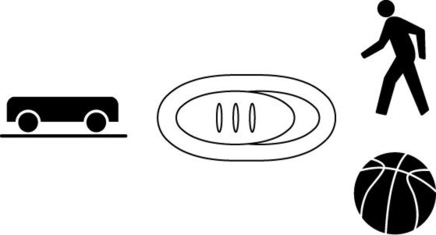
2. Use tape to fasten a small index card to the back of the car you will be using. The card acts as a reflective surface for the Motion Detector.
3. If your Motion Detector has a switch, set it to Track. Connect the Motion Detector to DIG 1 of LabQuest and choose New from the File menu. If you have an older sensor that does not auto-ID, manually set up the sensor.
4. On the Sensor screen, tap Rate. Change the data-collection rate to 5 samples/second and the data-collection length to 3 seconds.
5. Collect data.
- Place your car on the ramp with its front wheels at the 40 cm line.
- Start data collection and release the car after data collection begins.
6. Determine the velocity of the car.
- After data collection stops, examine the velocity vs. time graph. To examine the data pairs on the displayed graph, tap any data point. As you tap each data point, the velocity and time values of each data point are displayed to the right of the graph.
- The highest point on the graph corresponds to the highest velocity of the car. Record this highest velocity in the data table. Round to the nearest 0.01 m/s.
7. Repeat Steps 5–6 two more times.
8. Repeat Steps 5–7 at distances of 70 cm and 100 cm.

DATA
 | Velocity (m/s)
Release point | Trial 1 | Trial 2 | Trial 3 | Average
40 cm
70 cm
100 cm
PROCESSING THE DATA
1. Calculate the average velocity for each release point. Show your work here. Record the results in the data table.

2. Make a graph of your data. Plot Release Point (in cm) on the horizontal or x-axis and Average Velocity (in m/s) on the vertical or y-axis.
3. What happens to the velocity of the car as you release it from higher points?

4. How does friction affect the velocity of your car?

5. How could you improve your car to make it roll faster?

6. Describe one way you could change the ramp to make the car go faster, without changing the release points.

EXTENSIONS
1. Repeat the experiment with ramps of different heights.
2. Design, build, and test a different car.

