Graphing Your Motion
Graphs made using a Motion Detector can be used to study motion. In this experiment, you will use a Motion Detector to make graphs of your own motion.
OBJECTIVES
In this experiment, you will
- Use a Motion Detector to measure position, velocity, and acceleration.
- Use a computer to produce graphs of your motion.
- Analyze the graphs you produce.
- Match position vs. time and velocity vs. time graphs.
MATERIALS
LabQuest | masking tape
LabQuest App | meter stick
Motion Detector

PROCEDURE
Part A Position
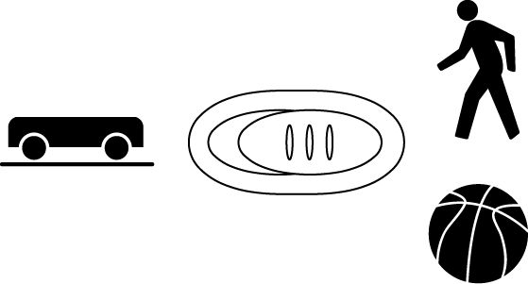
1. Find an open area at least 4 m long in front of a wall. Use short strips of masking tape on the floor to mark distances of 1 m, 2 m, and 3 m from the wall. You will be measuring distances from the Motion Detector in your hands to the wall.
2. If your Motion Detector has a switch, set it to Normal. Connect the Motion Detector to DIG 1 of LabQuest and choose New from the File menu. If you have an older sensor that does not auto-ID, manually set up the sensor.
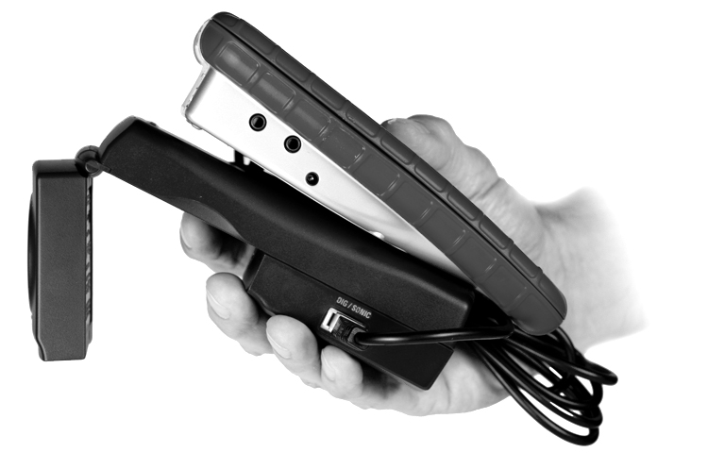
3. Open the hinge on the Motion Detector. When you collect data, hold the Motion Detector so the round, metal detector is always pointed directly at the wall. Sometimes you will have to walk backwards.
4. Monitor the position readings. Move back and forth and confirm that the values make sense.
5. Make a graph of your motion when you walk away from the wall with constant velocity. To do this, stand about 1 m from the wall and start data collection. Walk backward, slowly away from the wall after data collection begins.
6. Sketch what the graph will look like if you walk faster. Check your prediction with the Motion Detector. To take more data, start data collection when you are ready to begin walking.
7. Sketch your results.
8. Choose Motion Match ► New Position Match from the Analyze menu. A target graph will be displayed for you to match.
9. Write down how you would walk to reproduce the target graph. Sketch or print a copy of the graph.
10. To test your prediction, choose a starting position and stand at that point. Start data collection. Wait a moment and then walk in such a way that the graph of your motion matches the target graph on the screen.
11. If you were not successful, start data collection when you are ready to begin walking. Repeat this process until your motion closely matches the graph on the screen. Print or sketch the graph with your best attempt.
12. Perform a second distance graph match (Steps 8–10) by choosing Motion Match ► New Position Match again. This will generate a new target distance graph for you to match.

PROCESSING THE DATA (Part A)
1. Describe the difference between the two lines on your graph made in Steps 5 and 6. Explain why the lines are different.

- How would the graph change if you walked toward the wall rather than away from it? Test your answer.

3. What did you have to do to match the graph you were given in Step 9?
Part B Velocity
13. Choose New from the File menu.
14. Make a graph of your motion when you walk away from the wall with constant velocity. To do this, stand about 1 m from the wall and start data collection. Walk slowly away from the wall when you hear the Motion Detector begin to click. After data collection is complete, a graph of velocity vs. time will be displayed.
15. Sketch your results.
16. Sketch what the graph will look like if you walk faster. Check your prediction with the Motion Detector. To take more data, start data collection when you are ready to begin walking.
17. LabQuest can also generate random target velocity graphs for you to match. Choose Motion Match ► New Velocity Match from the Analyze menu to view a velocity target graph.
18. Write down how you would walk to produce this target graph. Sketch or print a copy of the graph.
19. To test your prediction, choose a starting position and stand at that point. start data collection, then walk in such a way that the graph of your motion matches the target graph on the screen. It will be more difficult to match the velocity graph than it was for the distance graph.
20. If you were not successful, start data collection when you are ready to start walking. Repeat this process until your motion closely matches the graph on the screen. Print or sketch the graph with your best attempt.
PROCESSING THE DATA (Part B)
4. Describe the difference between the two lines on the graph made in Steps 14 and 16. Explain why the lines are different.

5. What is the definition of velocity?

6. What did you have to do to match the graph you were given in Step 16? How well does your graph match the given graph?

7. Describe the motion needed to make this graph:
If it is a position vs. time graph:

If it is a velocity vs. time graph:

You can check your answers using a Motion Detector.

