Electromagnets
A magnetic field forms around a wire that has an electric current in it. Winding a wire around a piece of iron increases the strength of the magnetic field. A temporary magnet made in this way is called an electromagnet. In this experiment, you will use a Magnetic Field Sensor to study the relationship between number of wire winds and magnetic field strength of an electromagnet.
OBJECTIVES
In this experiment, you will
- Build an electromagnet.
- Measure magnetic field strength.
- Make conclusions about the relationship between number of wire winds and magnetic field strength.
MATERIALS
LabQuest | 1 m piece of insulated wire
LabQuest App | battery (size D)
Vernier Magnetic Field Sensor | tape
large iron nail

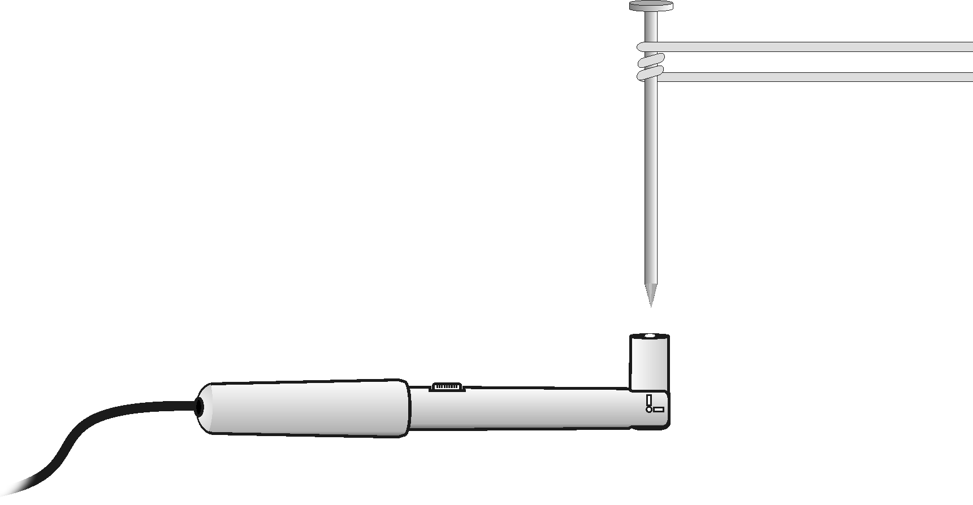
Figure 1
PROCEDURE
1. Set the Magnetic Field Sensor to 6.4 mT (low amplification) and bend the tip so it is perpendicular to the sensor (see Figure 1). Tape a Magnetic Field Sensor to the tabletop. The white dot should face up.
2. Connect the Magnetic Field Sensor to LabQuest and choose New from the File menu. If you have an older sensor that does not auto-ID, manually set up the sensor.
3. Set up LabQuest for data collection.
- On the Sensor screen, tap Mode. Change the data-collection mode to Events with Entry.
- Enter the Name (Winds) and leave the Units field blank. Select OK.
4. Zero the Magnetic Field Sensor.
- Make sure the Magnetic Field Sensor is far away from the anything magnetic.
- Hold the sensor so the white spot faces up and is parallel to the tabletop.
- When the readings on the screen stabilize, choose Zero from the Sensors menu. When the process is complete, the readings for the sensor should be close to zero.
5. Start data collection.
6. Collect data for zero winds.
- Get a large iron nail and place its pointed end perpendicular to the top of the Magnetic Field Sensor at its very end, as shown in Figure 1. When the reading has stabilized, tap Keep.
- Enter 0 (for 0 winds).
- Select OK. The magnetic field strength value for zero winds is now saved.
7. Tape one bare end of a 1 m insulated wire to the bottom end of a flashlight battery.
8. Place the nail on the wire at a position 10–15 cm from the battery. Tightly wind the wire around the nail 3 times as shown in Figure 1.
9. Collect data for 3 winds.
- Firmly press the other bare end of the wire to the top of the battery.
- A partner should again touch the pointed end of the nail to the top of the sensor at its very end as shown in Figure 1. Important: If the reading decreases, reverse the connections.
- When the reading has stabilized, tap Keep.
- Enter 3 (for 3 winds) and select OK. The magnetic field strength value for three winds is now saved.
10. Repeat Step 9 for 6, 9, 12, 15, 18, and 21 winds. Caution: The battery will become warm as it is used. To keep it from getting hot, and to save energy, remove the wire from the top of the battery immediately after you tap Keep. Important: Wrap all winds at nearly the same distance from the nail end.
11. Stop data collection.
12. Record the magnetic field strength values.
- When data collection is complete, a graph of magnetic field strength vs. number of winds will be displayed. To examine the data pairs on the displayed graph, tap any data point. As you tap each data point, the magnetic field strength values of each data point are displayed to the right of the graph.
- Record the magnetic field strength values.
13. Sketch or print the graph as directed by your teacher.
DATA
Winds  (number) | Magnetic field  (mT) | Winds  (number) | Magnetic field  (mT)
0 |  | 12
3 |  | 15
6 |  | 18
9 |  | 21
PROCESSING THE DATA
1. What is the relationship between number of winds and magnetic field strength?

2. According to your graph, what would the magnetic field strength reading be for 10 winds? For 30 winds? Explain.

EXTENSIONS
1. See how many grams of iron filings your electromagnet will pick up with the same numbers of winds used in the above experiment. Compare mass of iron filings picked up to magnetic field strength.
2. Compare the magnetic field of the nail after the experiment with its magnetic field before it has been used in an electromagnet. Measure the magnetic field of the nail again after striking it on a hard surface. Explain these results using the idea of magnetic domains.

