Mapping a Magnetic Field
The region around a magnet where magnetic force acts is called a magnetic field. In this experiment, you will map the magnetic field at one-centimeter intervals along a bar magnet.
OBJECTIVES
In this experiment, you will
- Measure and graph magnetic field strength at points along a bar magnet.
- Analyze data.
- Make conclusions about the magnetic field at various points on a bar magnet.
MATERIALS
LabQuest | bar magnet
LabQuest App | clear tape
Vernier Magnetic Field Sensor | ruler
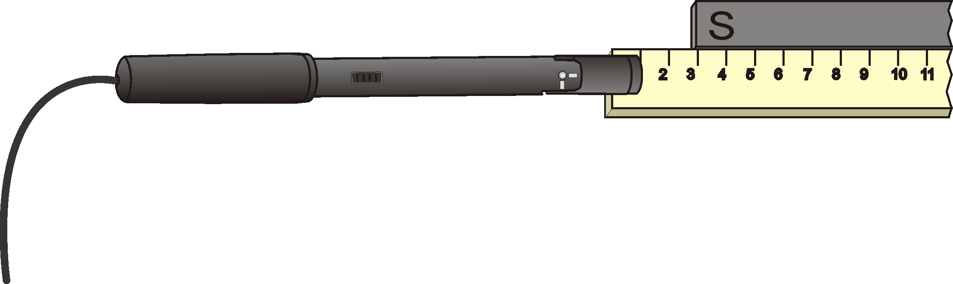
Figure 1
PROCEDURE
1. Using clear tape, tape a ruler to your desktop. Place a bar magnet beside the ruler. Position the S-pole end of the magnet at the 3 cm mark as shown in Figure 1. Tape the magnet to the tabletop.
2. Set the switch on the Magnetic Field Sensor to 6.4 mT (low amplification). Connect the Magnetic Field Sensor to LabQuest and choose New from the File menu. If you have an older sensor that does not auto-ID, manually set up the sensor.
3. Set up LabQuest for data collection.
- On the Meter screen, tap Mode. Change the data-collection mode to Events with Entry.
- Enter the Name (Distance) and Units (cm). Select OK.
4. Zero the Magnetic Field Sensor.
- Make sure the Magnetic Field Sensor is far away from the bar magnet.
- Hold the sensor so it is parallel to the tabletop.
- When the readings on the screen stabilize, choose Zero from the Sensors menu. When the process is complete, the readings for the sensor should be close to zero.
5. Start data collection.
6. Collect data at the 0 cm distance.
- Place the Magnetic Field Sensor perpendicular to the bar magnet as shown in Figure 1. Center the white spot at the 0 cm mark of the ruler. Keep the Magnetic Field Sensor parallel to the tabletop throughout the experiment. When the reading has stabilized, tap Keep.
- Enter 0 (for 0 cm) and select OK to save this data pair.
7. Move the sensor, and repeat the Step 6 procedure at 1 cm intervals until you have reached a point 3 cm beyond the N-pole end of the bar magnet.
8. When you have finished, stop data collection.
9. To examine the data pairs on the displayed graph, tap any data point. As you tap each data point, the magnetic field strength and distance values of each data point are displayed to the right of the graph. Record the magnetic field strength values.
10. Sketch or print the graph as directed by your teacher.

DATA
Distance  (cm) | Magnetic field  (mT) | Distance  (cm) | Magnetic field  (mT) | Distance  (cm) | Magnetic field  (mT)
0 |  | 9 |  | 18
1 |  | 10 |  | 19
2 |  | 11 |  | 20
3 |  | 12 |  | 21
4 |  | 13 |  | 22
5 |  | 14 |  | 23
6 |  | 15 |  | 24
7 |  | 16 |  | 25
8 |  | 17 |  | 26

PROCESSING THE DATA
1. Where on the bar magnet was the largest positive magnetic field strength reading observed?

2. Where on the bar magnet was the most negative magnetic field strength reading observed?

3. At what centimeter distance does your graph have a zero value magnetic field strength value? At what point is this on the bar magnet?

4. Why does the graph have both positive and negative magnetic field strength values?

EXTENSION
1. Test the strengths of different magnet types at the same distance from the sensor. Which magnet types are strongest? Weakest?

