Heart Rate and Exercise
Heart rates increase during exercise. The heart rates of physically fit people increase less during exercise than those of less fit people. The heart rates of physically fit people recover to their resting rates more rapidly. In this experiment, you will use a Heart Rate Monitor to measure your heart rate as you stand quietly for 100 seconds, step onto and off a stool for 100 seconds, and then stand quietly for 200 seconds. You will then analyze a graph of the results to determine your standing heart rate, your maximum heart rate during the 100 seconds of exercise, and your recovery time.
Important: Do not attempt this experiment if physical exertion will aggravate a health problem. Inform your teacher of any possible health problems that might be affected if you participate in this experiment.
OBJECTIVES
In this experiment, you will
- Use a Heart Rate Monitor to measure your heart rate.
- Determine the effect of exercise on your heart rate.
- Determine your recovery time.
- Compare your results with those of other students.
MATERIALS
LabQuest | timer
LabQuest App | stepping stool, 40 cm high
Vernier Hand-Grip Heart Rate Monitor or | saline solution in a dropper bottle
Vernier Exercise Heart Rate Monitor | (only for use with the Exercise HRM)
PROCEDURE
1. Connect the receiver module of the Heart Rate Monitor to LabQuest and choose New from the File menu. If you have an older sensor that does not auto-ID, manually set up the sensor.
2. On the Sensor screen, tap Rate. Change the data-collection length to 400 seconds.
3. Set up the Heart Rate Monitor. Follow the directions for your type of Heart Rate Monitor.
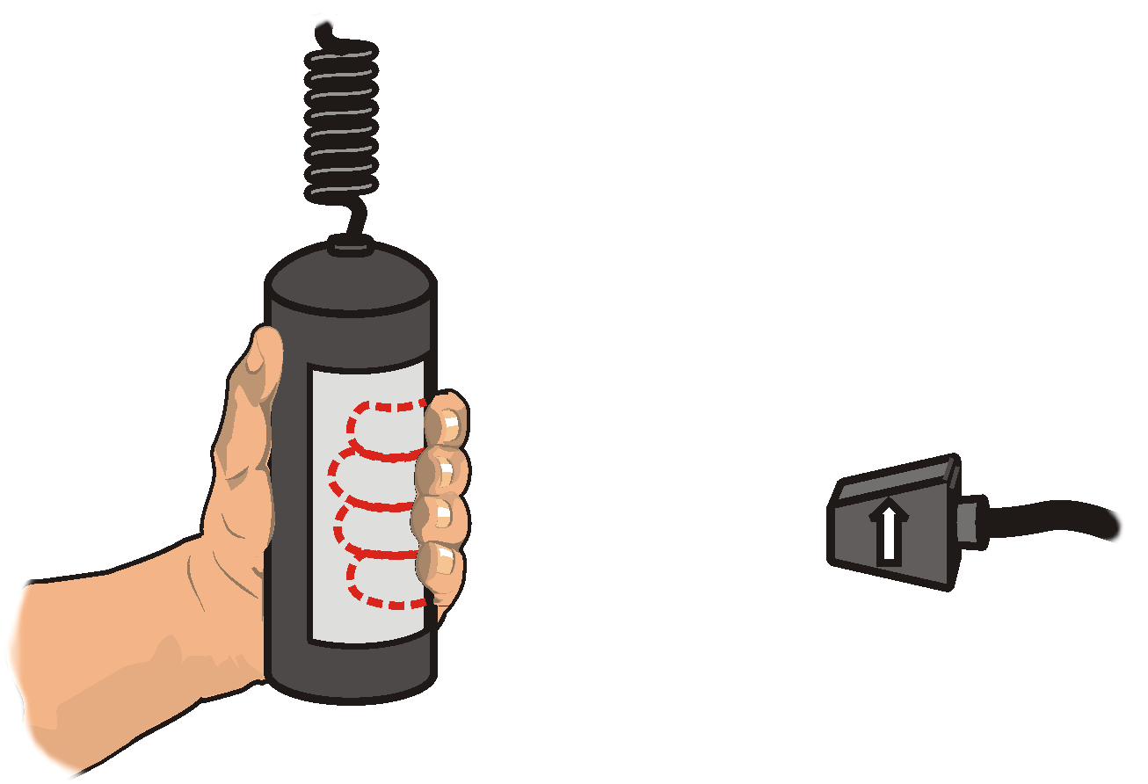
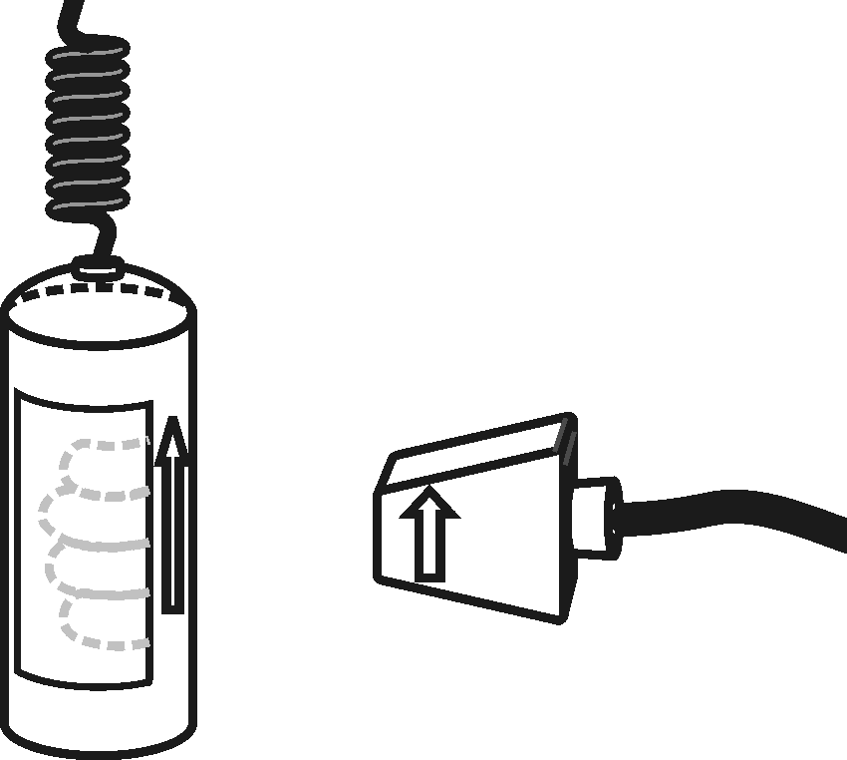
Using a Hand-Grip Heart Rate Monitor
Figure 1
Figure 2
- Grasp the handles of the Hand-Grip Heart Rate Monitor. Place the fingertips of each hand on the reference areas of the handles (see Figure 1).
- The left hand grip and the receiver are both marked with an alignment arrow. When collecting data, be sure that the arrow labels on each of these devices are in alignment (see Figure 2) and that they are not too far apart. The reception range of the plug-in receiver is 80–100 cm, or 3 feet.
Using an Exercise Heart Rate Monitor
- Depending upon your size, select a small- or large-size elastic strap. Secure one of the plastic ends of the elastic strap to the transmitter belt. It is important that the strap provide a snug fit of the transmitter belt.
- Wet each of the electrodes (the two textured oval areas on the underside of the transmitter belt) with 3 drops of saline solution.
- Secure the transmitter belt against the skin directly over the base of the rib cage (see Figure 3). The POLAR logo on the front of the belt should be centered. Adjust the elastic strap to ensure a tight fit.
- Take the receiver module of the Heart Rate Monitor in your right hand. Remember that the receiver must be within 80 cm of the transmitter in the Heart Rate Monitor belt.

4. Sit down, facing away from your classmates and the screen. Start data collection. Determine that the sensor is functioning correctly. The readings should be consistent and within the normal range of the individual, usually between 55 and 80 beats per minute. When you have determined that the equipment is operating properly, stop data collection and proceed to Step 5.
Figure 3
Part I Standing Heart Rate
5. Once the subject has been standing quietly for about a minute, a partner should start data collection. Another partner should begin timing at the same time. The subject should stand quietly for 100 seconds.
Part II Step Test
6. When 100 seconds have gone by, immediately begin to exercise as follows:
- Place your right foot on the top step of the stool.
- Place your left foot completely on the top step of the stool next to your right foot.
- Place your right foot back on the floor.
- Place your left foot completely on the floor next to your right foot.
- Each stepping cycle should take 3 seconds to complete.
- Continue the step test for a total of 100 seconds.
Part III Recovery Time
7. After 100 seconds of stepping (a total of exactly 200 seconds of data collection), stop stepping. Stand quietly for 200 seconds. Data collection will end automatically.
Part IV Recording Data
8. Examine the graph that is displayed after data collection ends. You should be able to recognize three parts of the graph that match with the standing, exercising, and recovery parts of the experiment.
9. Determine the subject’s standing heart rate.
- Identify the flattest part of the first 1/4 of the graph (up to about 100 seconds) that matches with the standing part of the experiment.
- Tap and drag your stylus across the flattest part of the region to select the data.
- Choose Statistics from the Analyze menu.
- Record the mean (average) heart rate (to the nearest whole bpm). This is the subject’s standing heart rate.
- Choose Statistics from the Analyze menu to turn off statistics.
10. Determine the subject’s maximum heart rate.
- To examine the data pairs on the displayed graph, tap any data point. As you tap each data point, the heart rates and time values are displayed to the right of the graph.
- Tap the highest point on the graph and record the time (in seconds) and the heart rate (to the nearest whole bpm) displayed for this point.
11. Determine the time when the subject’s standing heart rate returned to within 3 bpm of the standing rate.
- Starting at the highest point on the graph, tap the data points to the right.
- Stop where the displayed heart rate first reads within 3 bpm of the Step-13 value.
- Record the time (in seconds) for this point.
12. Sketch or print the graph as directed by your teacher.
13. Repeat Steps 3–12 with other members of the team serving as subjects.
DATA
Subject’s name
Standing heart rate (bpm)
Maximum heart rate (bpm)
Time at maximum heart rate (s)
Time at return to within 3 bpm of
standing rate (s)
Recovery time in seconds (s)

PROCESSING THE DATA
1. In the space provided in the data table, calculate the recovery time for each subject. (Subtract the time at maximum heart rate from the time when the rate returned to within 3 bpm of the standing rate.)
2. Compare the standing heart rates of the members of your group.

3. How does your maximum heart rate compare to other students in your group? Is this what you expected? How do you account for this?

4. How does your recovery time compare to other students in your group? Is this what you expected? How do you account for this?

5. Why would athletes need to work longer and harder before their heart rates were at the maximum value? Explain.

EXTENSION
1. Survey your classmates to determine how much they exercise each week. Determine if there is a relationship between amount of exercise and recovery time for your class.

