Heart Rate and Body Position
Does the position of your body affect your heart rate? In this experiment, you will use a Heart Rate Monitor to measure your heart rate while sitting, lying, and standing. You will then use your results to answer the questions.
OBJECTIVES
In this experiment, you will
- Use a Heart Rate Monitor to measure your heart rate while sitting, lying, and standing.
- Analyze the results of your experiment.
- Compare your results with those of other students.
- Answer the question posed in the introduction.
MATERIALS
LabQuest | timer
LabQuest App | saline solution in a dropper bottle
Vernier Hand-Grip Heart Rate Monitor or | (only for use with the Exercise HRM)
Vernier Exercise Heart Rate Monitor
PROCEDURE
1. Connect the receiver module of the Heart Rate Monitor to LabQuest and choose New from the File menu. If you have an older sensor that does not auto-ID, manually set up the sensor.
2. On the Sensor screen, tap Length. Change the data-collection length to 720 seconds.
3. Set up the Heart Rate Monitor. Follow the directions for your type of Heart Rate Monitor.
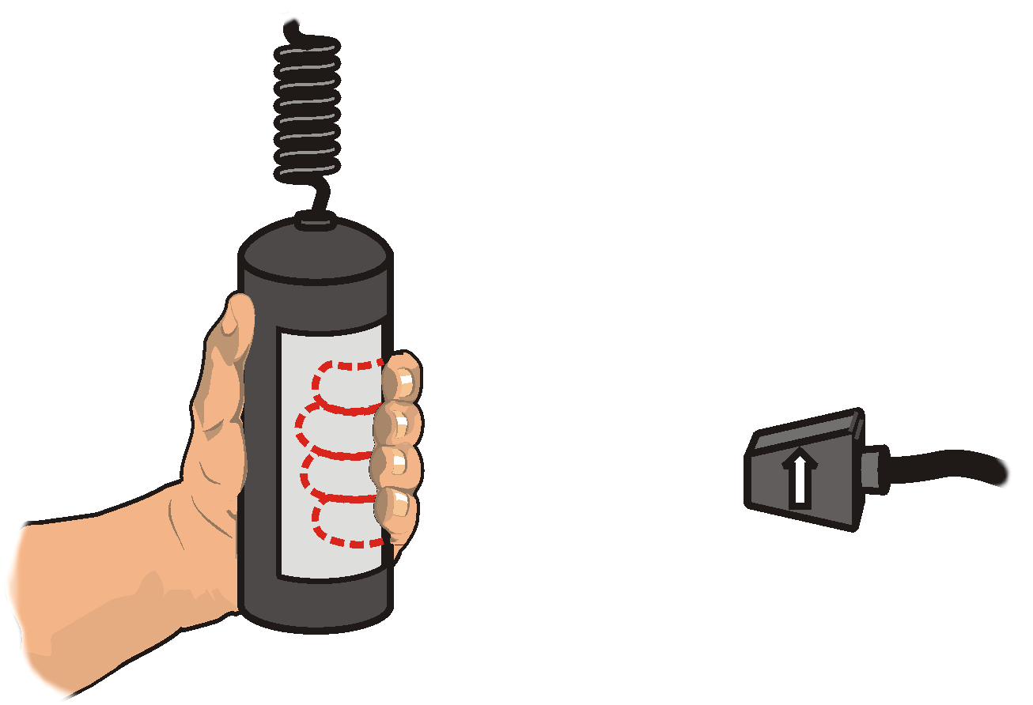
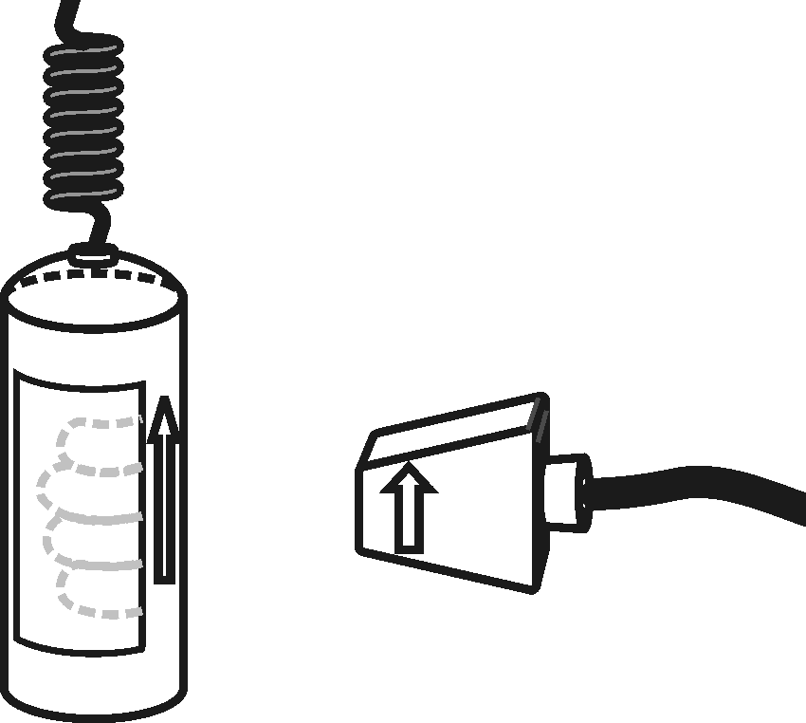
Using a Hand-Grip Heart Rate Monitor
Figure 1
Figure 2
- Grasp the handles of the Hand-Grip Heart Rate Monitor. Place the fingertips of each hand on the reference areas of the handles (see Figure 1).
- The left hand grip and the receiver are both marked with an alignment arrow. When collecting data, be sure that the arrow labels on each of these devices are in alignment (see Figure 2) and that they are not too far apart. The reception range of the plug-in receiver is 80–100 cm, or 3 feet.

Using an Exercise Heart Rate Monitor
- Depending upon your size, select a small- or large-size elastic strap. Secure one of the plastic ends of the elastic strap to the transmitter belt. It is important that the strap provide a snug fit of the transmitter belt.
- Wet each of the electrodes (the two textured oval areas on the underside of the transmitter belt) with 3 drops of saline solution.
- Secure the transmitter belt against the skin directly over the base of the rib cage (see Figure 3). The POLAR logo on the front of the belt should be centered. Adjust the elastic strap to ensure a tight fit.
- Take the receiver module of the Heart Rate Monitor in your right hand. Remember that the receiver must be within 80 cm of the transmitter in the Heart Rate Monitor belt.
4. Sit down, facing away from your classmates and the screen. Start data collection. Determine that the sensor is functioning correctly. The readings should be consistent and within the normal range of the individual, usually between 55 and 80 beats per minute. When you have determined that the equipment is operating properly, stop data collection and proceed to Step 5.
Figure 3
5. The subject should sit quietly. Once the subject has been seated quietly for about a minute, a partner should start data collection to begin monitoring heart rate. Another partner should begin timing at the same time.
6. After 4 minutes of data collection have gone by, the subject should recline on a clean surface or table and facing away from all classmates. Note: A partner should tell the subject when it is time to recline. The partner also needs to position the receiver so that it is aligned parallel to the arrows on the transmitter handles.
7. After 8 minutes of data collection have gone by, the subject should stand facing away from all classmates. A partner should again tell the subject when it is time to stand. Data collection will automatically stop after 12 minutes (720 seconds).
8. Examine the graph that is displayed after data collection ends. You should be able to recognize three parts that match with the subject’s sitting, reclining, and standing heart rates.
9. Determine the subject’s sitting heart rate.
- Identify the flattest part of the first 1/3 of the graph (up to about 240 seconds) that matches with the sitting part of the experiment.
- Tap and drag your stylus across the flattest part of the region to select the data.
- Choose Statistics from the Analyze menu.
- Record the Mean (average) heart rate (to the nearest whole bpm). This is the subject’s sitting heart rate.
- Choose Statistics from the Analyze menu to turn off statistics.
10. Determine the subject’s reclining heart rate.
- Identify the flattest part of the middle 1/3 of the graph (from about 240 seconds up to about 480 seconds) that matches with the reclining part of the experiment. Tap and drag your stylus across the region to select the data.
- Choose Statistics from the Analyze menu.
- Record the Mean (average) heart rate (to the nearest whole bpm). This is the subject’s reclining heart rate.
- Choose Statistics from the Analyze menu to turn off statistics.
11. Determine the subject’s standing heart rate.
- Note the flattest part of the last 1/3 of the graph (from about 480 seconds up to 720 seconds) that matches with the standing part of the experiment. Tap and drag your stylus across the region to select the data.
- Choose Statistics from the Analyze menu.
- Record the mean (average) heart rate (to the nearest whole bpm). This is the subject’s standing heart rate.
12. Sketch or print copies of the graph as directed by your teacher.
13. Repeat Steps 3–12 with other members of the team serving as subjects.
DATA
Subject’s name
Sitting heart rate (beats/min)
Reclining heart rate (beats/min)
Standing heart rate (beats/min)
Difference between sitting and reclining heart rates (beats/min)
Difference between standing and sitting heart rates (beats/min)
Difference between standing and reclining heart rates (beats/min)
PROCESSING THE DATA
1. In the space provided in the data table, subtract to calculate the difference between the sitting and reclining heart rates for each subject.
2. Subtract to find the difference between the standing and sitting heart rates for each subject.
3. Subtract to find the difference between the standing and reclining heart rates for each subject.
4. Does the position of your body affect your heart rate?

5. Compare your results with those of other students.

6. Try to explain the results of the experiment.
EXTENSION
1. Measure your heart rate while standing on your head. Compare the results with your other results.

