Graphing Your Motion
Graphs made using a Motion Detector can be used to study motion. In this experiment, you will use a Motion Detector to make graphs of your own motion.
OBJECTIVES
In this experiment, you will
- Use a Motion Detector to measure position, velocity, and acceleration.
- Use a computer to produce graphs of your motion.
- Analyze the graphs you produce.
- Match position vs. time and velocity vs. time graphs.
MATERIALS
computer | masking tape
Vernier computer interface | meter stick
Motion Detector

PROCEDURE
Part A Position
1. Fasten a Vernier Motion Detector to a tabletop facing an aisle. Connect the Motion Detector. If your Motion Detector has a sensitivity switch, set it to Normal.
2. Use short strips of masking tape on the floor to mark the 1 m, 2 m, 3 m, and 4 m positions from the Motion Detector.
3. Start the Vernier data-collection program and open the file “33a Graphing Motion” from the Middle School Science with Vernier folder.
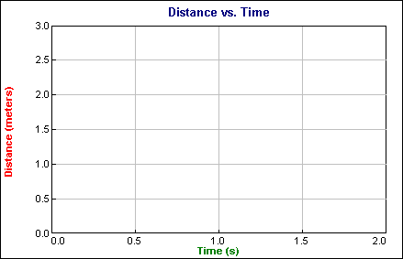
4. Stand at the 1 m position facing the Motion Detector and the computer screen. Have your partner click . Slowly walk backwards away from the Motion Detector and watch the screen.
5. Choose Store Latest Run from the Experiment menu. Repeat Step 4, moving faster this time.
6. Sketch your results on the above graph.
7. Open the file “33b Graph Matching.” You should see the following position vs. time graph.
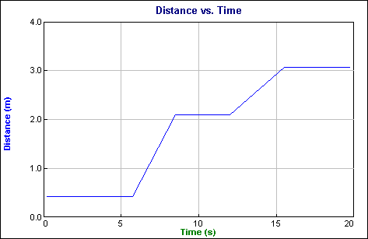
8. Try to match the line by moving toward or away from the Motion Detector. Sketch your results on the graph above. Have everyone in your group try to match the line.

PROCESSING THE DATA (Part A)
1. Describe the difference between the two lines on your graph made in Steps 4 and 5. Explain why the lines are different.

- How would the graph change if you walked toward the Motion Detector rather than away from it? Test your answer.

3. What did you have to do to match the graph you were given in Step 7?

Part B Velocity
9. Open the file “33c Graphing Motion.”
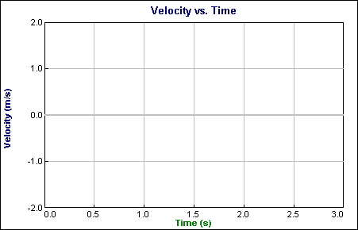
10. Stand at the 1 m position facing the Motion Detector and the computer screen. Have your partner click , then slowly walk backwards away from the Motion Detector.
11. Choose Store Latest Run on the Experiment menu. Repeat Step 10, moving faster this time.
12. Sketch your results on the graph above.
13. Open the file “33d Graphing Motion.” You should see the following velocity vs. time graph.
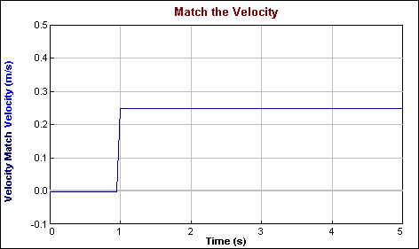
14. Try to match the line by moving toward or away from the Motion Detector. Sketch your results on the above graph. Have everyone in your group try to match the line.
PROCESSING THE DATA (Part B)
4. Describe the difference between the two lines on the graph made in Steps 10 and 11. Explain why the lines are different.

5. What is the definition of velocity?

6. What did you have to do to match the graph you were given in Step 13? How well does your graph match the given graph?

7. Describe the motion needed to make this graph:
If it is a position vs. time graph:

If it is a velocity vs. time graph:

You can check your answers using a Motion Detector.

Part C Acceleration
15. Open the file “33e Graphing Motion.”
16. Stand at the 1 m position, this time with your back to the Motion Detector. Have your partner click . Pause for about one second and then walk rapidly to the 3 m mark and stop. Say “stop” when you have stopped. As you say “stop,” your partner should click . Print or sketch your results.
PROCESSING THE DATA (Part C)
8. How does the acceleration vs. time graph differ from the other two graphs?

9. On your velocity vs. time graph, label the acceleration and deceleration portions.
10. On your acceleration vs. time graph, label the acceleration and deceleration portions.
11. What is acceleration?

EXTENSIONS
1. Create a graph-making challenge. Open the file “33f Graphing Motion”, which contains a blank position vs. time graph. Use Draw Prediction from the Analyze menu to draw a position vs. time graph and challenge another student in the class to match your graph. Have the other student challenge you in the same way.
2. Use the graph on Page 2 of the file “33f Graphing Motion” and the Draw Prediction feature to create a velocity vs. time challenge in a similar manner.
3. Create a position vs. time graph by walking in front of the Motion Detector. Store the graph by choosing Store Latest Run from the Experiment menu. Have another student match your run.
4. Create a velocity vs. time graph by walking in front of the Motion Detector. Store the graph by choosing Store Latest Run from the Experiment menu. Have another student match your run.

