Heart Rate and Exercise
Heart rates increase during exercise. The heart rates of physically fit people increase less during exercise than those of less fit people. The heart rates of physically fit people recover to their resting rates more rapidly. In this experiment, you will use a Heart Rate Monitor to measure your heart rate as you stand quietly for 100 seconds, step onto and off a stool for 100 seconds, and then stand quietly for 200 seconds. You will then analyze a graph of the results to determine your standing heart rate, your maximum heart rate during the 100 seconds of exercise, and your recovery time.
Important: Do not attempt this experiment if physical exertion will aggravate a health problem. Inform your teacher of any possible health problems that might be affected if you participate in this experiment.
OBJECTIVES
In this experiment, you will
- Use an Exercise Heart Rate Monitor to measure your heart rate.
- Determine the effect of exercise on your heart rate.
- Determine your recovery time.
- Compare your results with those of other students.
MATERIALS
computer | saline solution in dropper bottle
Vernier computer interface | (for use with Exercise HR Monitor)
Vernier Hand-Grip Heart Rate Monitor or | stepping stool, 40 cm high
Vernier Exercise Heart Rate Monitor
PROCEDURE
1. Plug the receiver module of the Heart Rate Monitor into the Vernier computer interface.
2. Start the Vernier data-collection program and open the file “26 Heart Rate Exercise” in the Middle School Science with Vernier folder.
Using a Hand-Grip Heart Rate Monitor
Use the following instructions if you are using a Hand-Grip Heart Rate Monitor.
3. Stand facing your table or lab bench. Grasp the handles of the Hand-Grip Heart Rate Monitor your hands. The fingertips of each hand should be placed on the reference areas of the handles. The left hand grip and the receiver are both marked with an alignment arrow. When collecting data, be sure that the arrow labels on each of these devices are in alignment (see Figure 1). The reception range of the plug-in receiver is 80−100 cm, or about 3 feet.
4. Click  to determine that the sensor is functioning correctly. There will be a 15 second delay while data are collected before the first point is plotted on the upper graph. Thereafter, a point will be plotted every 5 seconds. The readings should be consistent and within the normal range of the individual, usually between 55 and 90 beats per minute.
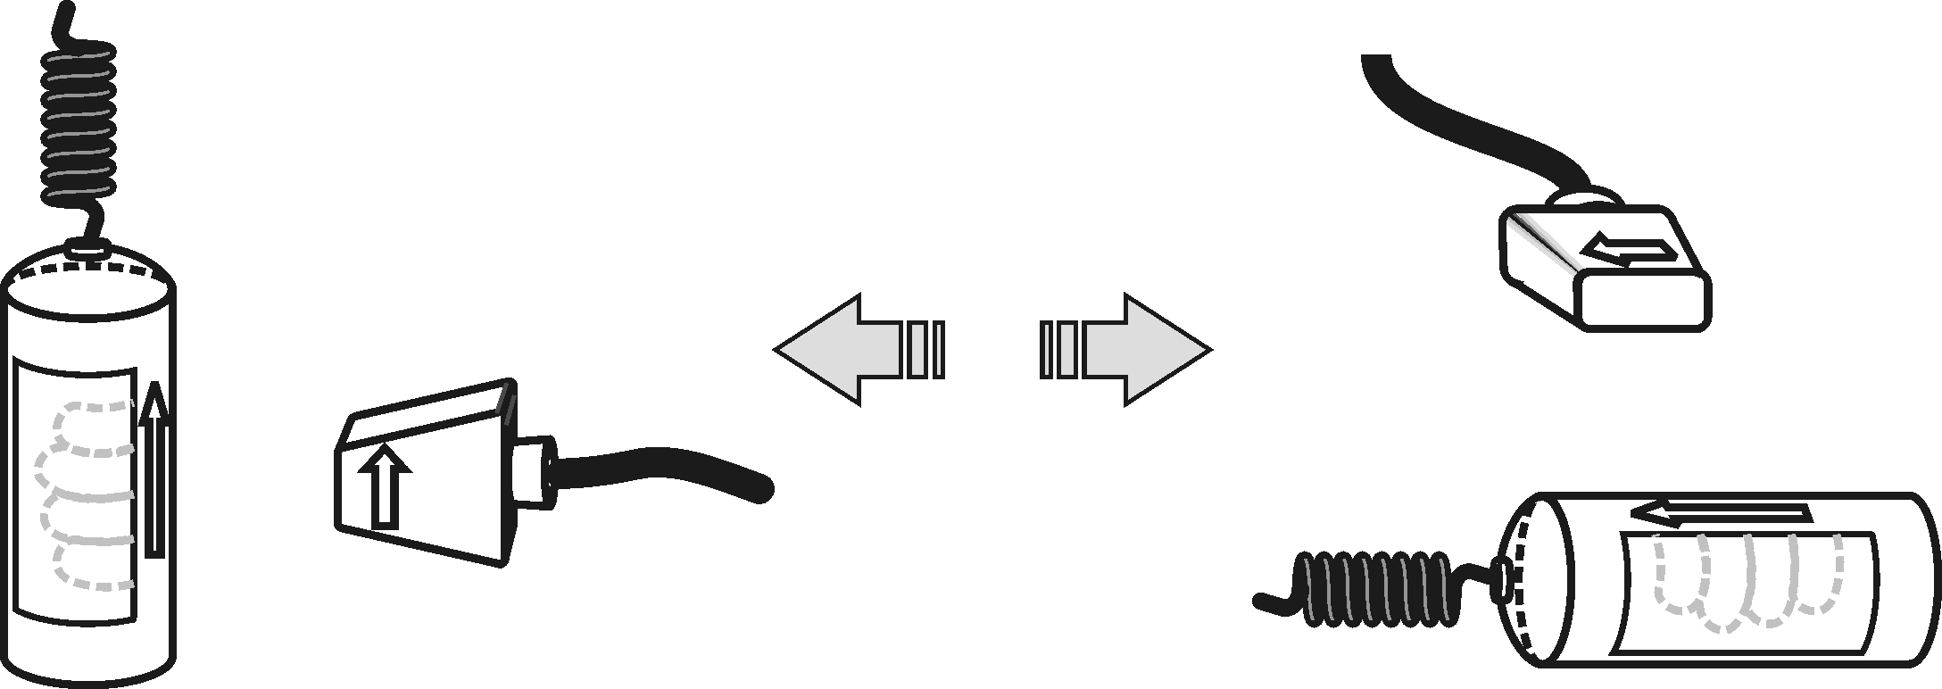
5. If the readings appear unreasonable, reposition your fingers and check the sensor and receiver alignment.
Figure 1
6. Once it is apparent that the sensor is functioning correctly, click  and continue with Step 11.
Using an Exercise Heart Rate Monitor
Use the following instructions if you are using an Exercise Heart Rate Monitor.
7. Depending upon your size, select a small or large size elastic strap. Secure one of the plastic ends of the elastic strap to the transmitter belt. It is important that the strap provide a snug fit of the transmitter belt.
Figure 2
8. Wet each of the electrodes (the two grooved rectangular areas on the underside of the transmitter belt) with 3 drops of saline solution.
9. Secure the transmitter belt against the skin directly over the base of the rib cage. The POLAR logo on the front of the belt should be centered. Adjust the elastic strap to ensure a tight fit.
10. Take the receiver module of the Heart Rate Monitor in your right hand and stand as far from the computer monitor as possible. Stand quietly. Remember that the receiver must be within 80 cm of the transmitter in the Heart Rate Monitor belt.
Part I Standing Heart Rate
11. Once the subject has been standing quietly for about a minute, a partner should click to begin monitoring heart rate. There will be a 30 second delay while data are collected before the first point is plotted on the upper graph. Thereafter, a point will be plotted every 5 seconds. The subject should stand quietly for 100 seconds.
Part II Step Test
12. When 100 seconds have gone by, immediately begin to exercise as follows:
- Place your right foot on the top step of the stool.
- Place your left foot completely on the top step of the stool next to your right foot.
- Place your right foot back on the floor.
- Place your left foot completely on the floor next to your right foot.
- Each stepping cycle should take 3 seconds to complete.
- Continue the step test for a total of 100 seconds.
Part III Recovery Time
13. After 100 seconds of stepping (a total of 200 seconds of data collection), stop stepping. Stand quietly for 200 seconds. Data collection will end automatically.
Part IV Recording Data
14. Determine the subject’s standing heart rate.
- Move the mouse pointer to the 0 second line.
- Press the mouse button and hold it down as you drag across the graph to the 100 second line to select this part of the graph.
- Click the Statistics button, 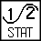. Record the Mean (average) standing heart rate (in bpm).
- Close the Statistics box.
15. Determine the subject’s maximum heart rate.
- Click on the Examine button, 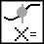.
- Move the cursor to the highest point on the graph.
- Record the heart rate (HRT) displayed for this point.
16. Determine the time when the subject’s standing heart rate returned to within 3 bpm of the standing rate.
- Starting at the 200 second line, move the cursor to the right.
- Stop where the displayed heart rate first reads within 3 bpm of the Step 10 value.
- Record the time (to the nearest whole second) for this point
- Close the Examine box.
17. Print copies of the graph as directed by your teacher.
18. Repeat Steps 3–17 with other members of the team serving as subjects.
DATA
Subject’s name
Standing heart rate (bpm)
Maximum heart rate (bpm)
Time at return to within 3 bpm of
standing rate (s)
Recovery time in seconds (s)
PROCESSING THE DATA
1. In the space provided in the data table, calculate the recovery time for each subject. (Subtract 200 from the time when the rate returned to within 3 bpm of the standing rate.)
2. Compare the standing heart rates of the members of your group.

3. How does your maximum heart rate compare to other students in your group? Is this what you expected? How do you account for this?

4. How does your recovery time compare to other students in your group? Is this what you expected? How do you account for this?

- Why would athletes need to work longer and harder before their heart rates were at the maximum value? Explain.

EXTENSION
1. Survey your classmates to determine how much they exercise each week. Determine if there is a relationship between amount of exercise and recovery time for your class.

