Heart Rate and Body Position
Does the position of your body affect your heart rate? In this experiment, you will use a Heart Rate Monitor to measure your heart rate while sitting, lying, and standing. You will then use your results to answer the question.
OBJECTIVES
In this experiment, you will
- Use a Hand-Grip Heart Rate Monitor or Exercise Heart Rate Monitor to measure your heart rate while sitting, lying, and standing.
- Analyze the results of your experiment.
- Compare your results with those of other students.
- Answer the question posed in the introduction.
MATERIALS
computer | Vernier Hand-Grip Heart Rate Monitor or
Vernier computer interface | Vernier Exercise Heart Rate Monitor
saline solution in dropper bottle
(for use with Exercise HR Monitor)
PROCEDURE
1. Plug the receiver module of the Heart Rate Monitor into the Vernier computer interface.
2. Start the Vernier data-collection program and open the file “25 Heart Rate Position” from the Middle School Science with Vernier folder.
Using a Hand-Grip Heart Rate Monitor
Use the following instructions if you are using a Hand-Grip Heart Rate Monitor.
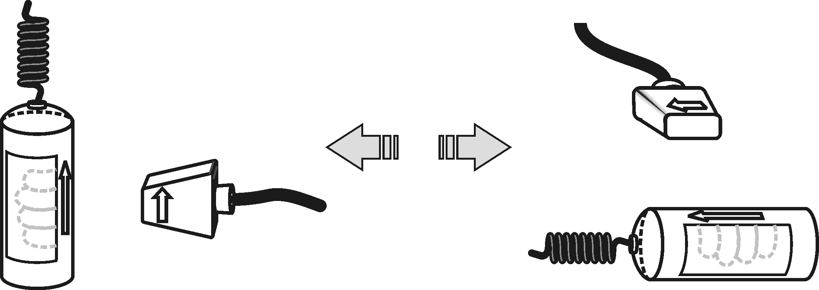
3. Stand facing your table or lab bench. Grasp the handles of the Hand-Grip Heart Rate Monitor your hands. The fingertips of each hand should be placed on the reference areas of the handles. The left hand grip and the receiver are both marked with an alignment arrow. When collecting data, be sure that the arrow labels on each of these devices are in alignment (see Figure 1). The reception range of the plug-in receiver is 80−100 cm, or about 3 feet.
Figure 1
4. Click  to determine that the sensor is functioning correctly. There will be a 15 second delay while data are collected before the first point is plotted on the upper graph. Thereafter, a point will be plotted every 5 seconds. The readings should be consistent and within the normal range of the individual, usually between 55 and 90 beats per minute.
5. If the readings appear unreasonable, reposition your fingers and check the sensor and receiver alignment.
6. Once it is apparent that the sensor is functioning correctly, click  and continue with Step 11.
Using an Exercise Heart Rate Monitor
Use the following instructions if you are using an Exercise Heart Rate Monitor.
7. Depending upon your size, select a small or large size elastic strap. Secure one of the plastic ends of the elastic strap to the transmitter belt. It is important that the strap provide a snug fit of the transmitter belt.
8. Wet each of the electrodes (the two textured oval areas on the underside of the transmitter belt) with 3 drops of saline solution.  9. Secure the transmitter belt against the skin directly over the base of the rib cage. The POLAR logo on the front of the belt should be centered. Adjust the elastic strap to ensure a tight fit. | Figure 2
10. Take the receiver module of the Heart Rate Monitor in your right hand and have a seat well away from the computer monitor. Face away from the computer monitor and your classmates. Sit quietly. Remember that the receiver must be within 80 cm of the transmitter in the Heart Rate Monitor belt.
Part I Sitting Heart Rate
11. Once the subject has been seated quietly for about a minute, a partner should click to begin monitoring heart rate.
Part II Reclining Heart Rate
12. After 4 minutes of data collection have gone by, the subject should recline on a clean surface or table and facing away from the computer monitor and all classmates. Note: A partner should tell the subject when it is time to recline.
Part III Standing Heart Rate
13. After 8 minutes of data collection have gone by, the subject should stand facing away from the computer monitor and all classmates. A partner should again tell the subject when it is time to stand. Data collection will automatically stop after 12 minutes.
Part IV Recording Data
14. Determine the subject’s sitting heart rate.
- Move the mouse pointer to the 2 minute line.
- Press the mouse button and hold it down as you drag across the graph to the 4 minute line to select this part of the graph.
- Click the Statistics button,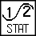. Record the Mean (average) sitting heart rate (in bpm).
15. Determine the subject’s reclining heart rate.
- Move the mouse pointer to the 6 minute line.
- Press the mouse button and hold it down as you drag across the graph to the 8-minute line to select this part of the graph.
- Click the Statistics button, . Record the Mean (average) reclining heart rate (in bpm).
16. Determine the subject’s standing heart rate.
- Move the mouse pointer to the 10 minute line.
- Press the mouse button and hold it down as you drag across the graph to the 12-minute line to select this part of the graph.
- Click the Statistics button, . Record the Mean (average) standing heart rate (in bpm).
- Close all of the Statistics boxes.
17. Print copies of the graph as directed by your teacher.
18. Repeat Steps 3–17 with other members of the team serving as subjects.
DATA
Subject’s name
Sitting heart rate (beats/min)
Reclining heart rate (beats/min)
Standing heart rate (beats/min)
Difference between sitting and reclining heart rates (beats/min)
Difference between standing and sitting heart rates (beats/min)
Difference between standing and reclining heart rates (beats/min)
PROCESSING THE DATA
1. In the space provided in the data table, subtract to calculate the difference between the sitting and reclining heart rates for each subject.
2. Subtract to find the difference between the standing and sitting heart rates for each subject.
3. Subtract to find the difference between the standing and reclining heart rates for each subject.
4. Does the position of your body affect your heart rate?

5. Compare your results with those of other students.

6. Try to explain the results of the experiment.

EXTENSION
1. Measure your heart rate while standing on your head. Compare the results with your other results.

