A Speedy Slide
You have been familiar with playgrounds and slides since you were a small child. The force of gravity pulls you down a slide. The force of friction slows you down. In the first part of this experiment, you will use a Motion Detector to determine your speed or velocity going down a playground slide. In the second part, you will experiment with different ways to increase your speed going down the slide.
OBJECTIVES
In this experiment, you will
- Use a Motion Detector to determine your speed going down a slide.
- Experiment with ways to increase your speed going down the slide.
- Explain your results.
MATERIALS
TI-83 Plus or TI-84 Plus graphing calculator
EasyData application
CBR 2 or Go! Motion and direct calculator cable
or Motion Detector and data-collection interface
playground slide

Figure 1
PROCEDURE
Part I Sliding Speed
1. Connect the Motion Detector.
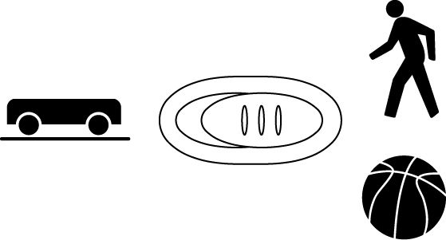
- Open the pivoting head of the Motion Detector.
- If the Motion Detector has a sensitivity switch, set it to Normal.
- Turn on the calculator and connect it to the Motion Detector. (This may require the use of a data-collection interface.)

2. Set up EasyData for data collection.
- Start the EasyData application, if it is not already running.
- Select  from the Main screen, and then select New to reset the application.
- Select  from the Main screen, then select Time Graph…
- Select  on the Time Graph Settings screen.
- Enter 0.2 as the time between samples in seconds.
- Select .
- Enter 25 as the number of samples and select . Data collection will last 5 seconds.
- Select  to return to the Main screen.

3. Take your preliminary data-collection positions.
- One member of the group should first go up the slide steps and sit at the top of the slide.
- A second person, while holding the Motion Detector, should go high enough on the slide steps to hold the Motion Detector behind the person who will slide.
- The third person should stand on the ground next to the slide, while holding the calculator and interface.
4. Take your final data-collection positions.
- The slider, while holding on, should move forward enough to allow a 50 cm distance between his or her back and the Motion Detector.
- The person holding the Motion Detector should hold the Motion Detector steady and aim it at the slider’s backside.
- The person holding the calculator and interface should move to a comfortable position that does not cause a pull on the Motion Detector cable.
5. Collect data.
- Select  to begin data collection.
- Then, tell the slider to start sliding.
- When data collection is done for this trial, the person with the Motion Detector should come down to the ground. Caution: No student should attempt to pass another person while he or she is on the steps.
6. Determine the slider’s speed.
- After data collection stops, a graph of distance versus time will be displayed. To view the velocity versus time graph, select , and then select Vel(m/s) vs Time.
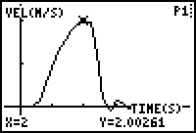
- Use  and  to examine data points along the graph. As you move the cursor right and left, the time (X) and velocity (Y) values of each data point are displayed above the graph. The highest point on the graph corresponds to the highest speed of the slider. Record this highest speed in the Data table. Round to the nearest 0.01 m/s. (In the example to the right, the highest speed is 2.00 m/s.)
- Select  to return to the Main screen.
7. Repeat Steps 3–6 two more times. Note: After selecting , select to overwrite the previous data and begin data collection.
Part II A Speedier Slide
8. Design a plan to increase the slider’s speed.
- Try out some ideas for increasing the slider’s speed. You may not coat the slide with anything that must be washed off.
- Decide on a plan to best increase the slider’s speed.
- Describe your plan in the Speedier Slide Plan section below.
9. Test your plan using Steps 3–7.
SPEEDIER SLIDE PLAN

DATA
 | Speed (m/sec)
 | Trial 1 | Trial 2 | Trial 3 | Average
Part I
Part II

PROCESSING THE DATA
1. Calculate the average speed for your three trials in Part I. Record the average in the space provided in the data table. Calculate and record the average speed for Part II.

2. Subtract your Part I average speed from your Part II average speed to determine how much your team improved its speed.

3. What methods did other groups use to improve their speeds?

4. Which of the methods worked best? Explain why it worked best.

5. If you could increase the height of the slide, how would the slider’s speed be affected?

6. If a stone was dropped from the top of the slide at the same time similar stone was rolled down the slide, which stone would reach the ground first? Explain.

7. What is the purpose of the level portion at the bottom of many slides?

EXTENSIONS
1. Design and carry out a plan to measure your speed or velocity on a different piece of playground equipment.
2. Have a contest to see who in your class or group can obtain the greatest speed going down a slide.

