Falling Objects
Galileo tried to prove that all falling objects accelerate downward at the same rate. Falling objects do accelerate downward at the same rate in a vacuum. Air resistance, however, can cause objects to fall at different rates in air. Air resistance enables a skydiver’s parachute to slow his or her fall. Because of air resistance, falling objects can reach a maximum velocity or terminal velocity. In this experiment, you will study the velocities of two different falling objects.
OBJECTIVES
In this experiment, you will
- Use a Motion Detector to measure distance and velocity.
- Produce distance vs. time and velocity vs. time graphs.
- Analyze and explain the results.
MATERIALS
TI-83 Plus or TI-84 Plus graphing calculator | metal rod
EasyData application | right-angle clamp
CBR 2 or Go! Motion and direct calculator cable | basket coffee filter
or Motion Detector and data-collection interface | 3 books
ring stand | meter stick

Figure 1

PROCEDURE
Part A Falling Coffee Filter
1. Set up the apparatus as shown in Figure 1.
- Place two books on the base of a ring stand to keep it from falling.
- Use a right-angle clamp to fasten a metal rod to the ring stand.
- Fasten a Motion Detector under one end of the rod. The Motion Detector should face down and be parallel to the floor.
- Move the right-angle clamp, rod, and Motion Detector to the top of the ring stand.
- Use a piece of tape to mark a spot on the ring stand that is 50 cm from the right-angle clamp.
- Place the ring stand, with the Motion Detector attached, at the edge of your lab table. The Motion Detector must extend 50 cm beyond the table edge.
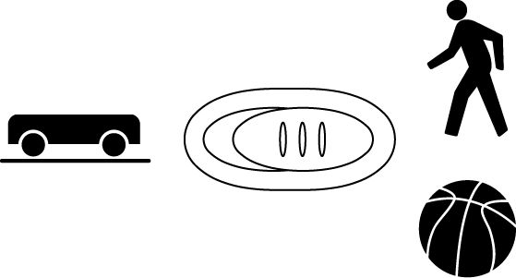
2. Connect the Motion Detector.
- Open the pivoting head of the Motion Detector.
- If the Motion Detector has a sensitivity switch, set it to Normal, as shown.
- Turn on the calculator and connect it to the Motion Detector. (This may require the use of a data-collection interface.)

3. Set up EasyData for data collection.
- Start the EasyData application, if it is not already running.
- Select  from the Main screen, and then select New to reset the application.
- Select  from the Main screen, then select Time Graph…
- Select  on the Time Graph Settings screen.
- Enter 0.1 as the time between samples in seconds.
- Select .
- Enter 30 as the number of samples and select . Data collection will last 3 seconds.
- Select  to return to the Main screen.

4. Collect data for a falling coffee filter.
- Hold a basket coffee filter with the open side facing up at a position 0.5 m from (at the 0.5 m mark on the ring stand) and directly below the Motion Detector.
- Select  to begin data collection.
- When you hear sound coming from the Motion Detector, allow the coffee filter to drop straight down.
5. Examine the distance vs. time graph for the falling coffee filter.
- When data collection is complete, a graph of distance versus time will be displayed.
- Examine the graph and discuss it with your lab partners. If it is satisfactory, sketch the graph in the space provided in the Data section. Label the important features of your graph. If necessary, repeat the drop. Note: After selecting , select to overwrite the previous data and begin data collection.
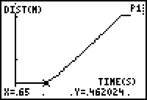
Landing Point
Drop Point
- Position the cursor at the filter’s drop point. See the example above. Record the time (X) and distance (Y) in the data table (round to the nearest 0.01). In the example above, the time is 0.65 s and distance is 0.46 m.
- Position the cursor at the filter’s landing point. See the example above for the location of the landing point. Record the time (X) and distance (Y) when the filter landed (to the nearest 0.01).
6. Examine the velocity vs. time graph for the falling coffee filter.
- To view the velocity versus time graph, select , and then select Vel(m/s) vs Time.
- Examine the graph and discuss it with your lab partners. Sketch the graph in the space provided in the Data section. Label the important features of your graph.
- Position the cursor at the highest point on the velocity vs. time graph. Record this highest velocity (Y) in the data table (round to the nearest 0.01 m/s).
Part B Falling Book
7. Collect data for a falling book.
- Select  to return to the Main screen.
- Repeat Steps 4–6 using a book.
DATA
Falling Coffee Filter

Falling Book

 | Falling coffee filter |  | Falling book
 | Distance (Y) | Time (X) | Distance (Y) | Time (X)
Drop point | m | s | m | s
Landing point | m | s | m | s
Highest velocity | m/s |  | m/s
PROCESSING THE DATA
1. Calculate the distance fallen (in m) for each object. (Subtract the drop-point distance from the landing-point distance.)
Falling Coffee Filter Falling Book

2. How do the distances compare? Why do the distances compare this way?

3. Calculate the falling time (in s) for each object. (Subtract the drop-point time from the landing-point time.)
Falling Coffee Filter Falling Book

4. How do the falling times compare?

5. Which object fell faster? Why?

6. How are the two distance vs. time graphs different? Explain the differences.

7. How are the two velocity vs. time graphs different? Explain the differences.

8. Compare the highest velocities of your two objects. Which object was falling faster when it landed? Why was it falling faster?

9. For which object is air resistance more important? Why does air resistance affect this object more than the other object?

10. Which of your velocity vs. time graphs would be more like the velocity vs. time graph of an object falling in a vacuum? Why?

11.

On the graph to the left, sketch a velocity vs. time curve for an object that is released at 0.5 s, falls with increasing velocity until 1.5 s, falls at constant velocity from 1.5 s to 3.0 s, and lands at 3.0 s. An object that falls at constant velocity is said to have reached terminal velocity.

12. Did either of your objects reach terminal velocity? If so, which one? How do you know?

EXTENSIONS
1. Determine the average terminal velocity of a coffee filter in five falls.
2. Study the falling behavior of stacks of 1, 2, 3, 4, and 5 coffee filters.

