Graphing Your Motion
Graphs made using a Motion Detector can be used to study motion. In this experiment, you will use a Motion Detector to make graphs of your own motion.
OBJECTIVES
In this experiment, you will
- Use a Motion Detector to measure distance and velocity.
- Produce graphs of your motion.
- Analyze the graphs you produce.
- Match distance vs. time and velocity vs. time graphs.
MATERIALS
TI-83 Plus or TI-84 Plus graphing calculator | masking tape
EasyData application | meter stick
CBR 2 or Go! Motion and direct calculator cable
or Motion Detector and data-collection interface

PROCEDURE
Part I Distance vs. Time Graphs
1. Fasten a Motion Detector to a tabletop facing an area free of furniture and other objects. The Motion Detector should be at a height of about 15 cm above your waist level.
2. Use short strips of masking tape on the floor to mark the 1 m, 2 m, 3 m, and 4 m distances from the Motion Detector.
3. Connect the Motion Detector.
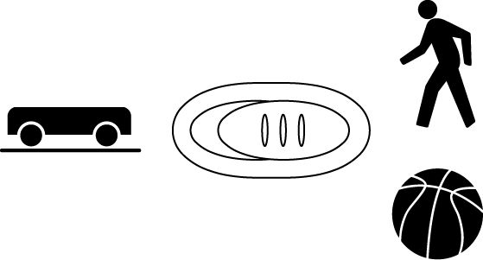
- Open the pivoting head of the Motion Detector.
- If the Motion Detector has a sensitivity switch, set it to Normal.
- Turn on the calculator and connect it to the Motion Detector. (This may require the use of a data-collection interface.)

4. Set up EasyData for data collection.
- Start the EasyData application, if it is not already running.
- Select  from the Main screen, and then select New to reset the application.

5. Explore making distance vs. time graphs.
- Stand at the 1.0 m mark, facing away from the Motion Detector.
- Signal your partner to select .
- Slowly walk to the 2.5 m mark and stop.
- When data collection ends, a graph of distance versus time will be displayed.
- Sketch your graph on the empty graph provided at the right.
- Select  to return to the Main screen.
6. Repeat Step 5 while walking faster. Sketch your new line on the same graph.
Part II Matching Distance vs. Time Graphs
7. Set up the calculator and interface for distance vs. time graph matching.
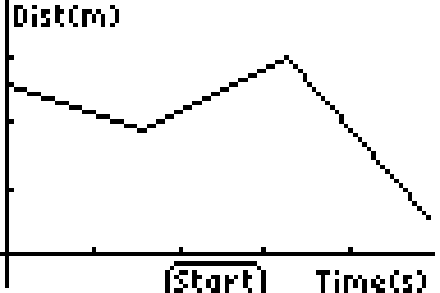
- Select  from the Main screen, then select Distance Match.
- Select , then , then  after reading the Distance Match information.
- EasyData randomly generates matching graphs like the one shown here; your graph may be different.
8. Match the first distance vs. time graph.
- Examine the graph and plan what you will do to match it. Note: The vertical axis runs from 0 to 3 meters. Data will be collected for 10 seconds.
- Take your starting position in front of the Motion Detector.
- When you are ready to begin matching, signal your partner to select .
- Move according to your plan.
- Examine the graph of the results.
- Sketch your results on Graph 1 below. Describe what you had to do to match the first graph. Sketch the graph you were matching and the graph of your motion.
- If you want to repeat the first match, select . If you are ready to move on to a second graph, select .
9. Repeat Step 8 until you have matched a total of three distance vs. time graphs.

PROCESSING THE DATA (Part I)
1. Describe the differences between your two graphs.

PROCESSING THE DATA (Part II)
2. Sketch your results in the empty graphs provided below. Describe what you had to do to match each of the graphs.
Graph What I did to match my graph:

Graph 1

Graph 2

Graph 3

Part III Velocity vs. Time Graphs
10. Explore making velocity vs. time graphs.
- Select from the Main screen, and then select New to prepare to collect new data.
- Take a starting position at the 1 m mark in front of the Motion Detector.
- Signal your partner to select .
- Stand still for one second, and then walk to the 3 m mark (away from the Motion Detector) at constant velocity.
- Stand still for one second, then walk backwards to the 1 m mark (toward the Motion Detector) at constant velocity.
- When data collection ends, a graph of distance versus time will be displayed. To see the velocity graph, select , then select Vel(m/s) vs Time.
- Sketch your velocity vs. time graph below.
PROCESSING THE DATA (Part III)
3. How does this velocity vs. time graph differ from your distance vs. time graphs made in Steps 5 and 8?

Part IV Matching Velocity vs. Time Graphs
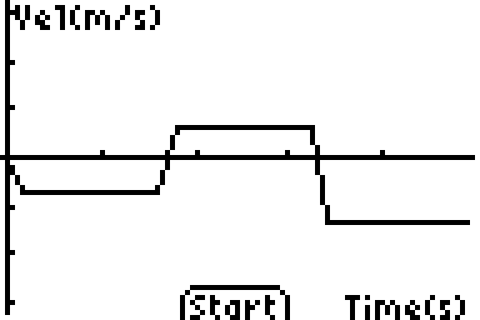
11. Set up the calculator and interface for velocity vs. time graph matching.
- Select to return to the Main screen.
- Select from the Main screen, then select Velocity Match.
- Select , then to overwrite the latest run.
- Select after reading the Graph Match information to display a randomly generated velocity vs. time graph.
12. Match the first velocity vs. time graph.
- Examine the graph and plan what you will do to match it. Data will be collected for ten seconds.
- Take your starting position in front of the Motion Detector.
- Signal your partner to select .
- Move according to your plan.
- Examine the graph of the results.
- Sketch your results on Graph 1 below. Describe what you had to do to match the first graph. Show the graph you were matching and the graph of your motion.
- If you want to repeat the first match, select . If you are ready to move on to a second graph, select .
13. Repeat Step 12 for a second velocity vs. time graph.
PROCESSING THE DATA (Part IV)
4. Sketch your results in the empty graphs provided below. Describe what you had to do to match each of the graphs.
Graph What I did to match my graph:
Graph 1

Graph 2
EXTENSIONS
1. Create a graph-making challenge. Sketch a distance vs. time graph on a piece of paper and challenge another student in the class to match your graph. Have the other student challenge you in the same way.
2. Create a velocity vs. time challenge in a similar manner.

