Electromagnets
A magnetic field forms around a wire that has an electric current in it. Winding a wire around a piece of iron increases the strength of the magnetic field. A temporary magnet made in this way is called an electromagnet. In this experiment, you will use a Magnetic Field Sensor to study the relationship between number of wire winds and magnetic field strength of an electromagnet.
OBJECTIVES
In this experiment, you will
- Build an electromagnet.
- Measure magnetic field strength.
- Make conclusions about the relationship between number of wire winds and magnetic field strength.
MATERIALS
TI-83 Plus or TI-84 Plus graphing calculator | large iron nail
EasyData application | 1 m piece of insulated wire
data-collection interface | battery (size D)
Vernier Magnetic Field Sensor | tape

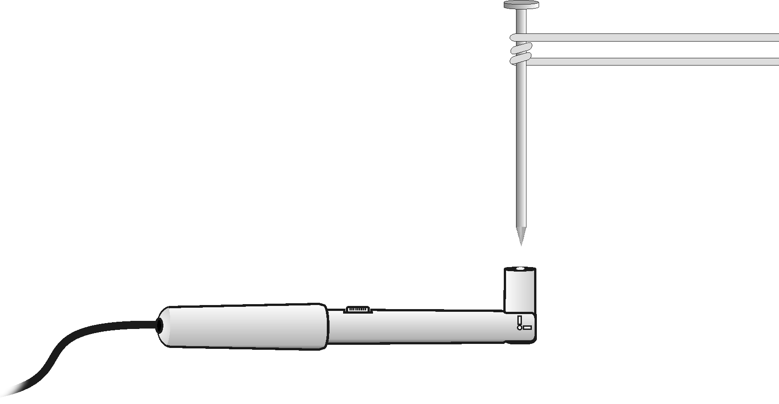
Figure 1
PROCEDURE
1. Turn on the calculator. Set the Magnetic Field Sensor to the 6.4 mT position and bend the tip so it is perpendicular to the sensor (see Figure 1). Connect the Magnetic Field Sensor, data-collection interface, and calculator.
2. Tape a Magnetic Field Sensor to the tabletop. The white side of the sensor (or white dot) should face up and be parallel to the tabletop.
3. Set up EasyData for data collection.
- Start the EasyData application, if it is not already running.
- Select  from the Main screen, and then select New to reset the application.
- Select  from the Main screen, and then select Events with Entry.

4. Zero the Magnetic Field Sensor.
- Select from the Main screen, and then select Zero…
- Select  to zero the Magnetic Field Sensor.
5. Select  to begin data collection.
6. Collect data for zero winds.
- Get a large iron nail and place its pointed end perpendicular to the top of the Magnetic Field Sensor at its very end, as shown in Figure 1.
- When the reading has stabilized, select .
- Enter 0 (for 0 winds) and select .

7. Tape one bare end of a 1 m insulated wire to the bottom end of a flashlight battery.
8. Place the nail on the wire at a position 10–15 cm from the battery. Tightly wind the wire around the nail 3 times as shown in Figure 1.
9. Collect data for 3 winds.
- Firmly press the other bare end of the wire to the top of the battery.
- A partner should again touch the pointed end of the nail to the top of the sensor at its very end as shown in Figure 1. Important: If the reading decreases, reverse the connections.
- When the reading has stabilized, select .
- Enter 3 (for 3 winds).
- Select . The magnetic field strength value for 3 winds is now saved.
10. Repeat Step 9 for 6, 9, 12, 15, 18, and 21 winds. Caution: The battery will become warm as it is used. To keep it from getting hot, and to save energy, remove the wire from the top of the battery immediately after has been selected. Important: Wrap all winds at nearly the same distance from the nail end.
11. Press  to end data collection.
12. Record the magnetic field strength values.
- When data collection ends, a graph of magnetic field strength vs. number of winds will be displayed. Use  and  to examine data points along the curve. As you move the cursor right or left, the number of winds (X) and magnetic field strength (Y) values of each data point are displayed above the graph.
- Record the magnetic field strength values.
13. Sketch or print the graph as directed by your teacher.
DATA
Winds  (number) | Magnetic field  (mT) | Winds  (number) | Magnetic field  (mT)
0 |  | 12
3 |  | 15
6 |  | 18
9 |  | 21
PROCESSING THE DATA
1. What is the relationship between number of winds and magnetic field strength?

2. According to your graph, what would the magnetic field strength reading be for 10 winds? For 30 winds? Explain.

EXTENSIONS
1. See how many grams of iron filings your electromagnet will pick up with the same numbers of winds used in the above experiment. Compare mass of iron filings picked up to magnetic field strength.
2. Compare the magnetic field of the nail after the experiment with its magnetic field before it has been used in an electromagnet. Measure the magnetic field of the nail again after striking it on a hard surface. Explain these results using the idea of magnetic domains.

