Mapping a Magnetic Field
The region around a magnet where magnetic force acts is called a magnetic field. In this experiment, you will map the magnetic field at one-centimeter intervals along a bar magnet.
OBJECTIVES
In this experiment, you will
- Measure and graph magnetic field strength at points along a bar magnet.
- Analyze data.
- Make conclusions about the magnetic field at various points on a bar magnet.
MATERIALS
TI-83 Plus or TI-84 Plus graphing calculator | bar magnet
EasyData application | clear tape
data-collection interface | ruler
Vernier Magnetic Field Sensor

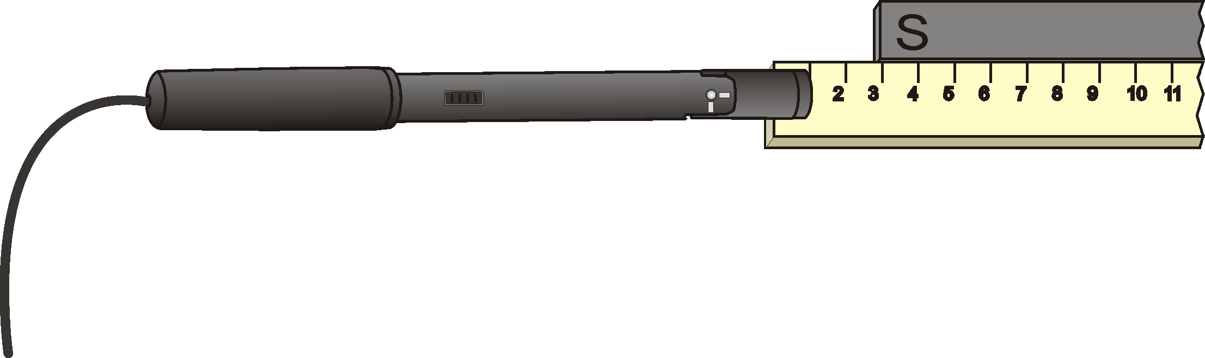
Figure 1
PROCEDURE
1. Using clear tape, tape a ruler to your desktop. Place a bar magnet beside the ruler. Position the S-pole end of the magnet at the 3 cm mark as shown in Figure 1. Tape the magnet to the tabletop.
2. Set up the Magnetic Field Sensor.
- Turn on the calculator.
- Set the Magnetic Field Sensor to the 6.4 mT position.
- Connect the Magnetic Field Sensor, data-collection interface, and calculator.

3. Set up EasyData for data collection.
- Start the EasyData application, if it is not already running.
- Select  from the Main screen, and then select New to reset the application.
- Select  from the Main screen, and then select Events with Entry.

4. Zero the Magnetic Field Sensor.
- Make sure the Magnetic Field Sensor is far away from the bar magnet.
- Hold the sensor so the white spot faces up and is parallel to the tabletop.
- Select from the Main screen, and then select Zero…
- Select  to zero the Magnetic Field Sensor.
5. Select  to begin data collection.
6. Collect data at the 0 cm distance.
- Place the Magnetic Field Sensor parallel to the bar magnet as shown in Figure 1. Center the white spot at the 0 cm mark of the ruler. Rotate the Magnetic Field Sensor so the white spot faces up and is parallel to the tabletop. Keep the white spot parallel to the tabletop throughout the experiment. When the reading has stabilized, select .
- Type 0 (for 0 cm) and select .
7. Move the sensor, and repeat the Step 6 procedure at 1 cm intervals until you have reached a point 3 cm beyond the N-pole end of the bar magnet.
8. Select  to end data collection.
9. Record the magnetic field strength values.
- When data collection ends, a graph of magnetic field strength vs. distance will be displayed. Use  and  to examine data points along the curve. As you move the cursor right or left, the distance (X) and magnetic field strength (Y) values of each data point are displayed above the graph.
- Record the magnetic field strength values.
10. Sketch or print the graph as directed by your teacher.
DATA
Distance  (cm) | Magnetic field  (mT) | Distance  (cm) | Magnetic field  (mT) | Distance  (cm) | Magnetic field  (mT)
0 |  | 9 |  | 18
1 |  | 10 |  | 19
2 |  | 11 |  | 20
3 |  | 12 |  | 21
4 |  | 13 |  | 22
5 |  | 14 |  | 23
6 |  | 15 |  | 24
7 |  | 16 |  | 25
8 |  | 17 |  | 26
PROCESSING THE DATA
1. Where on the bar magnet was the largest positive magnetic field strength reading observed?

2. Where on the bar magnet was the most negative magnetic field strength reading observed?

3. At what centimeter distance does your graph have a zero value magnetic field strength value? At what point is this on the bar magnet?

4. Why does the graph have both positive and negative magnetic field strength values?

EXTENSION
1. Test the strengths of different magnet types at the same distance from the sensor. Which magnet types are strongest? Weakest?

