Heart Rate and Body Position
Does the position of your body affect your heart rate? In this experiment, you will use a Heart Rate Monitor to measure your heart rate while sitting, lying, and standing. You will then use your results to answer the question.
OBJECTIVES
In this experiment, you will
- Use a Heart Rate Monitor to measure your heart rate while sitting, lying, and standing.
- Analyze the results of your experiment.
- Compare your results with those of other students.
- Answer the question posed in the introduction.
MATERIALS
TI-83 Plus or TI-84 Plus graphing calculator | data-collection interface
EasyData application | timer
Vernier Hand-Grip Heart Rate Monitor or | saline solution in a dropper bottle
Vernier Exercise Heart Rate Monitor | (only for use with the Exercise HRM)
PROCEDURE
1. Turn on the calculator. Connect the receiver module of the Heart Rate Monitor, data-collection interface, and calculator.
2. Set up EasyData for data collection.
- Start the EasyData application, if it is not already running.
- Select  from the Main screen, and then select New to reset the application.
- Select  from the Main screen, then select Rate…
- Select  from the Rate Mode Settings screen.
- Enter 10 as the time between samples in seconds.
- Select .
- Enter 72 as the number of samples and select . Data collection will last 720 seconds (12 minutes).
- Select  to return to the Main screen.

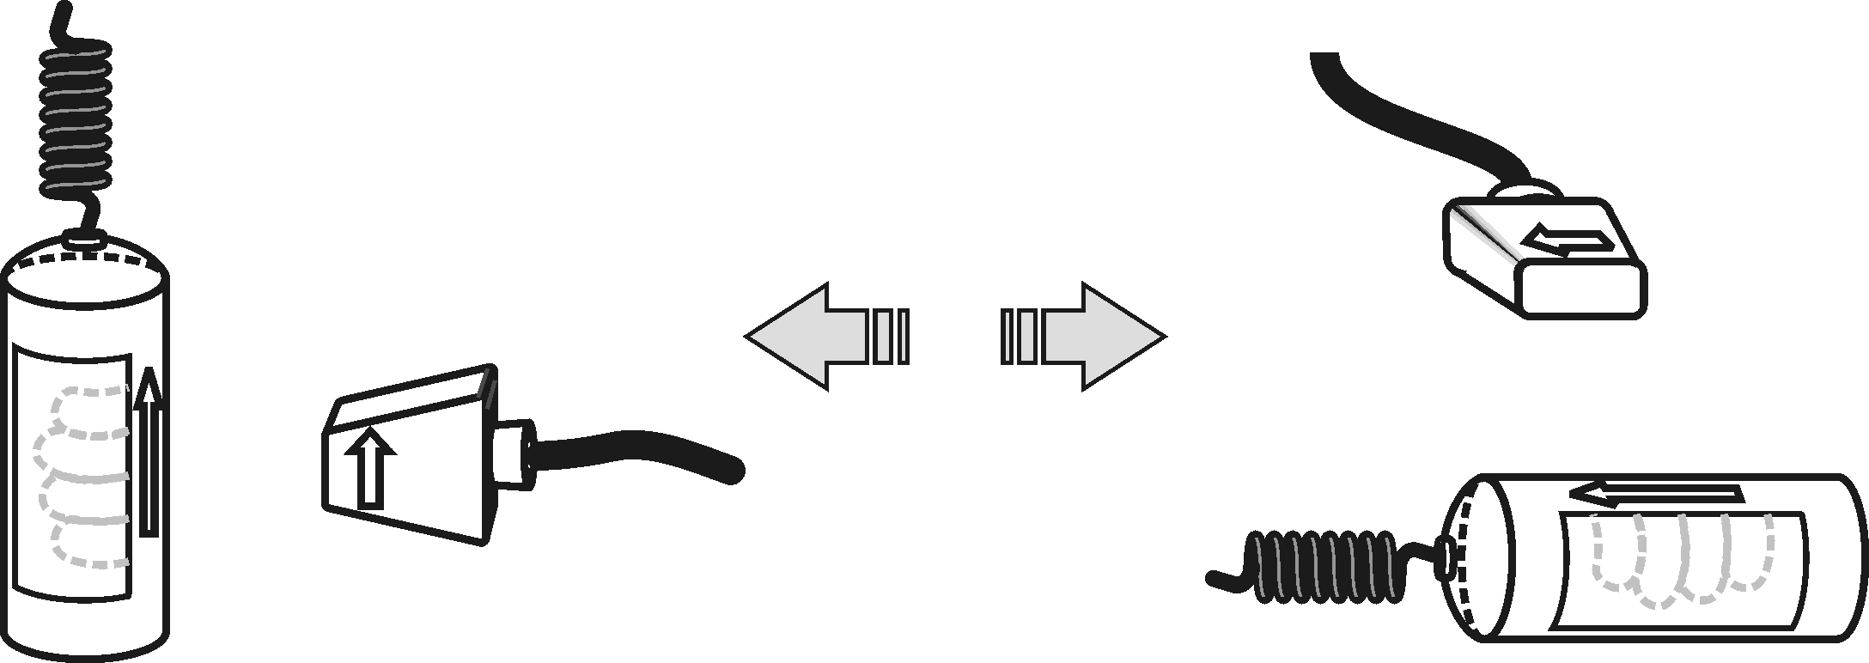
3. Set up the Heart Rate Monitor. Follow the directions for your type of Heart Rate Monitor.
Figure 1
Using a Hand-Grip Heart Rate Monitor
- Sit in a chair, facing away from the calculator and your classmates. Grasp the handles of the Hand-Grip Heart Rate Monitor your hands. The fingertips of each hand should be placed on the reference areas of the handles. The left hand grip and the receiver are both marked with an alignment arrow. When collecting data, be sure that the arrow labels on each of these devices are in alignment (see Figure 1). The reception range of the plug-in receiver is 80−100 cm, or about 3 feet.
- Monitor the live readouts on the calculator screen to determine that the sensor is functioning correctly. There will be a 10–15 second delay while data are collected before the first heart rate is reported. The readings should be consistent and within the normal range of the individual, usually between 55 and 90 beats per minute.
- If the readings appear unreasonable, reposition your fingers and check the sensor and receiver alignment.
- Once it is apparent that the sensor is functioning correctly, continue with Step 4.

Using an Exercise Heart Rate Monitor
- Depending upon your size, select a small or large size elastic strap. Secure one of the plastic ends of the elastic strap to the transmitter belt. It is important that the strap provide a snug fit for the transmitter belt.
- Wet each of the electrodes (the two grooved rectangular areas on the underside of the transmitter belt) with 3 drops of saline solution.  - Secure the transmitter belt against the skin directly over the base of the rib cage. The POLAR logo on the front of the belt should be centered. Adjust the strap for a tight fit. | Figure 2
- Take the receiver module of the Heart Rate Monitor in your right hand and have a seat. Face away from your classmates. Sit quietly. Remember that the receiver must be within 80 cm of the transmitter in the Heart Rate Monitor belt.
Part I Sitting Heart Rate
4. Once the subject has been seated quietly and reasonable readings have been obtained for about a minute, a partner should select  to begin monitoring heart rate. Another partner should begin timing at the same time.
Part II Reclining Heart Rate
5. After 4 minutes of data collection have gone by, the subject should recline on a clean surface or table and facing away from all classmates. Note: A partner should tell the subject when it is time to recline.
Part III Standing Heart Rate
6. After 8 minutes of data collection have gone by, the subject should stand facing away from all classmates. A partner should again tell the subject when it is time to stand. Data collection will automatically stop after 12 minutes (720 seconds).
Part IV Recording Data
7. Examine the graph that is displayed after data collection ends. You should be able to recognize three parts that match with the subject’s sitting, reclining, and standing heart rates.
8. Determine the subject’s sitting heart rate.
- Select , and then select Statistics…
- Note the flattest part of the first 1/3 of the graph (up to about 240 seconds) that matches with the sitting part of the experiment.
- Use  and  to move the cursor to the beginning of this flattest part and then select .
- Move the cursor to the end of the flat part and select .
- Record the mean (average) heart rate (to the nearest whole bpm). This is the subject’s sitting heart rate.
- Select to return to the graph.
9. Determine the subject’s reclining heart rate.
- Select , and then select Statistics…
- Note the flattest part of the middle 1/3 of the graph (from about 240 seconds up to about 480 seconds) that matches with the reclining part of the experiment.
- Use and to move the cursor to the beginning of this flattest part and select .
- Move the cursor to end of this flat part and select .
- Record the mean (average) heart rate (to the nearest whole bpm). This is the subject’s reclining heart rate.
- Select to return to the graph.
10. Determine the subject’s standing heart rate.
- Select , and then select Statistics…
- Note the flattest part of the last 1/3 of the graph (from about 480 seconds up to 720 seconds) that matches with the standing part of the experiment.
- Use and to move the cursor to the beginning of this flattest part and select .
- Move the cursor to end of this flat part and select .
- Record the mean (average) heart rate (to the nearest whole bpm). This is the subject’s standing heart rate.
- Select to return to the graph.
11. Sketch or print copies of the graph as directed by your teacher.
12. Repeat Steps 4–11 with other members of the team serving as subjects. Note: After selecting , select to begin data collection.
DATA
Subject’s name
Sitting heart rate (beats/min)
Reclining heart rate (beats/min)
Standing heart rate (beats/min)
Difference between sitting and reclining heart rates (beats/min)
Difference between standing and sitting heart rates (beats/min)
Difference between standing and reclining heart rates (beats/min)
PROCESSING THE DATA
1. In the space provided in the data table, subtract to calculate the difference between the sitting and reclining heart rates for each subject.
2. Subtract to find the difference between the standing and sitting heart rates for each subject.
3. Subtract to find the difference between the standing and reclining heart rates for each subject.
4. Does the position of your body affect your heart rate?

5. Compare your results with those of other students.

6. Try to explain the results of the experiment.

EXTENSION
1. Measure your heart rate while standing on your head. Compare the results with your other results.

