Ocean Floor Mapping
Oceanographers, marine geologists, and archeologists use sound to investigate objects below the surfaces of bodies of water. A signal is sent out and bounces back from a submerged surface. Scientists use the speed of sound in water and the time it takes for the signal to bounce back to calculate the depth of the object. Sonar is the name given to this system. The Motion Detector works in a similar manner. In this activity, you will use a Motion Detector to map objects on a simulated ocean floor.
OBJECTIVES
In this experiment, you will
- Use a Motion Detector to measure distances.
- Map simulated ocean floors.
- Analyze graphs to find the heights of objects on a simulated ocean floor.
MATERIALS
TI-83 Plus or TI-84 Plus graphing calculator | 1 m board
EasyData application | masking tape
CBR 2 or Go! Motion and direct calculator cable | 2 or more boxes
or Motion Detector and data-collection interface

Figure 1

PROCEDURE
Part I Ocean Floor 1
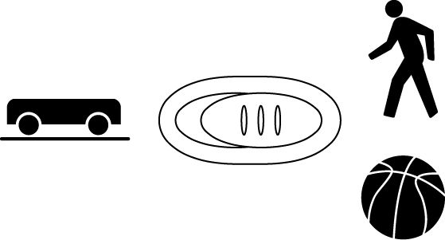
1. Connect the Motion Detector.
- Open the pivoting head.
- If the Motion Detector has a sensitivity switch, set it to Normal.
- Turn on the calculator and connect it to the Motion Detector. (This may require the use of a data-collection interface).

2. Prepare the Motion Detector for data collection.
- Get the board that will act as the support for your Motion Detector.
- Tape or clamp the Motion Detector to one end of the board. Make sure that the round screen of the Motion Detector is not covered and is pointing downward.
- Place the board with the Motion Detector flat on your table as shown in Figure 1.
3. Prepare the ocean floor for data collection.
- Place the box on the floor underneath the Motion Detector. Note: The Motion Detector must be at least 40 cm from the top of the box.
- Line up the Motion Detector so that when it is moved along the table edge it will pass over the box.
4. Set up EasyData for data collection.
- Start the EasyData application, if it is not already running.
- Select  from the Main screen, and then select New to reset the application.
- Select  from the Main screen, then select Time Graph…
- Select  on the Time Graph Settings screen.
- Enter 0.25 as the time between samples in seconds and select .
- Enter 60 as the number of samples and select . Data collection will last 15 seconds.
- Select  to return to the Main screen.

5. Collect distance data.
- Move the board to position the Motion Detector to the left of the box.
- When everything is ready, select  to begin data collection.
- After data collection begins, slowly slide the board across the tabletop so that the Motion Detector passes over and past the box.
6. Determine the distance to the floor.
- When data collection is complete, a graph of distance versus time will be displayed. To determine the distance to the floor, select , and then select Statistics…
- Identify a flat portion of the graph that represents the floor. Use  and  to move the cursor to the left bound of this flat portion and then select .
- Move the cursor to the right bound of this flat portion and select .
- In your data table, record the mean (average) distance to the floor in meters.
- Select to return to the graph.
7. Determine the distance to the box.
- To determine the distance to the box, select , and then select Statistics…
- Identify a flat portion of the graph that represents the box. Move the cursor to the left bound of this flat portion and select .
- Move the cursor to the right bound of this flat portion and select .
- Record the mean (average) distance to the box in meters.
- Select and then select  to return to the Main screen.
8. Sketch and label your graph.
Part II Ocean Floor 2
9. Prepare Ocean Floor 2.
- Set up two boxes in the shape of steps. The tallest box must be at least 40 cm from the Motion Detector.
- Repeat Steps 5–8. Be sure to record all three distances.
Part III Hidden Ocean Floor
10. Your teacher will have a hidden ocean floor for you to measure. Repeat Steps 5–8 for the concealed object or objects.
DATA
 | Distance to  floor (m) | Distance to  box (m) | Box height  (m)
Ocean floor 1
single box
Ocean floor 2
box 1
Ocean floor 2
box 2
Hidden ocean floor
box 1
Hidden ocean floor
box 2
Hidden ocean floor
box 3
Graph Sketches

Ocean Floor 1 Ocean Floor 2 Hidden Ocean Floor

PROCESSING THE DATA
1. In the space provided in the data table above, find the height of each box. Do this by subtracting the distance to the box from the distance to the floor.
2. Which was your best result? Why do you think it was better than your other results?
3. How did the shape of your graph compare to the actual object(s) in each case? Explain.
4. What factors might affect the accuracy of real ocean-floor mapping?
EXTENSIONS
1. Try other hidden ocean-floor arrangements.
2. Research the sonar process and compare it to what you did in this activity.

