Heart Rate and Body Position
Does the position of your body affect your heart rate? In this experiment, you will use a Heart Rate Monitor to measure your heart rate while sitting, lying, and standing. You will then use your results to answer the question.
OBJECTIVES
In this experiment, you will
- Use a Heart Rate Monitor to measure your heart rate while sitting, lying, and standing.
- Analyze the results of your experiment.
- Compare your results with those of other students.
- Answer the question posed in the introduction.
MATERIALS
LabPro or CBL 2 interface | Vernier Hand-Grip Heart Rate Monitor or
 | Vernier Exercise Heart Rate Monitor
TI graphing calculator | saline solution in a dropper bottle
DataMate program | timer
PROCEDURE
1. Plug the Hand-Grip or Exercise Heart Rate Monitor into Channel 1 of the LabPro or CBL 2 interface. Use the link cable to connect the TI graphing calculator to the interface. Firmly press in the cable ends.
2. Turn on the calculator and start the DATAMATE program. Press  to reset the program.
3. Set up the calculator and interface for the Exercise Heart Rate Monitor. Note: Both the Hand-Grip and Exercise Heart Rate Monitors use the same receiver and calibration information. Therefore, set up the experiment for an Exercise Heart Rate Monitor no matter which type you are using.
- Select SETUP from the main screen.
- If the calculator displays HEART RT (BPM) in CH 1, proceed directly to Step 4. If it does not, continue with this step to set up your sensor manually.
- Press  to select CH 1.
- Select HEART RATE from the SELECT SENSOR menu.
- Select EX HEART RATE (BPM) from the HEART RATE menu.
4. Set up the calculator and interface for data collection.
- Use  and  to select MODE and press .
- Select TIME GRAPH from the SELECT MODE menu.
- Select CHANGE TIME SETTINGS from the TIME GRAPH SETTINGS menu.
- Enter 10 as the time between samples in seconds.
- Enter 72 as the number of samples. Data collection will last 720 seconds (12 minutes).
- Select OK to return to the setup screen.
- Select OK again to return to the main screen.
Using a Hand-Grip Heart Rate Monitor
Use the following instructions if you are using a Hand-Grip Heart Rate Monitor.
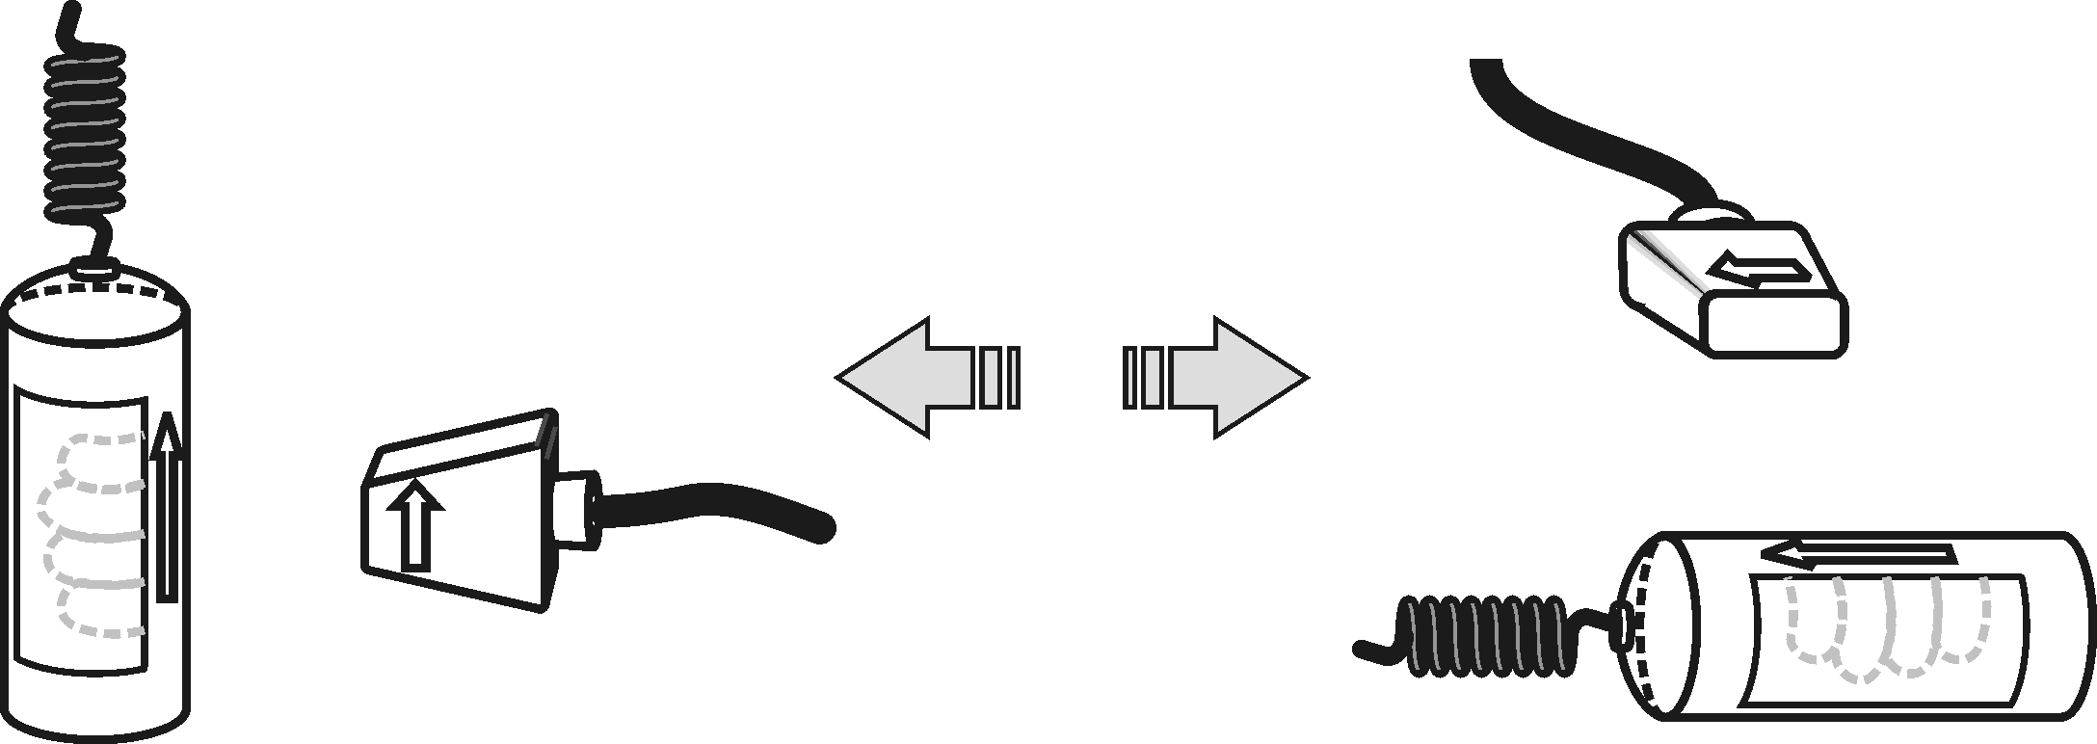
5. Stand facing your table or lab bench. Grasp the handles of the Hand-Grip Heart Rate Monitor your hands. The fingertips of each hand should be placed on the reference areas of the handles. The left hand grip and the receiver are both marked with an alignment arrow. When collecting data, be sure that the arrow labels on each of these devices are in alignment (see Figure 1). The reception range of the plug-in receiver is 80−100 cm, or about 3 feet.
Figure 1
4. Monitor the live readouts on the calculator screen to determine that the sensor is functioning correctly. There will be a 10–15 second delay while data are collected before the first heart rate is reported. The readings should be consistent and within the normal range of the individual, usually between 55 and 90 beats per minute.
5. If the readings appear unreasonable, reposition your fingers and check the sensor and receiver alignment.
6. Once it is apparent that the sensor is functioning correctly, continue with Step 11.
Using an Exercise Heart Rate Monitor
Use the following instructions if you are using an Exercise Heart Rate Monitor.
7. Depending upon your size, select a small or large size elastic strap. Secure one of the plastic ends of the elastic strap to the transmitter belt. It is important that the strap provide a snug fit for the transmitter belt.
8. Wet each of the electrodes (the two grooved rectangular areas on the underside of the transmitter belt) with 3 drops of saline solution.  9. Secure the transmitter belt against the skin directly over the base of the rib cage. The POLAR logo on the front of the belt should be centered. Adjust the strap for a tight fit. | Figure 1
10. Take the receiver module of the Heart Rate Monitor in your right hand and have a seat. Face away from your classmates. Sit quietly. Remember that the receiver must be within 80 cm of the transmitter in the Heart Rate Monitor belt.
Part I Sitting Heart Rate
11. Once the subject has been seated quietly for about a minute, a partner should select START to begin monitoring heart rate. Another partner should begin timing at the same time.
Part II Reclining Heart Rate
12. After 4 minutes of data collection have gone by, the subject should recline on a clean surface or table and facing away from all classmates. Note: A partner should tell the subject when it is time to recline.
Part III Standing Heart Rate
13. After 8 minutes of data collection have gone by, the subject should stand facing away from all classmates. A partner should again tell the subject when it is time to stand. Data collection will automatically stop after 12 minutes (720 seconds).
Part IV Recording Data
14. Examine the graph that is displayed after data collection ends. You should be able to recognize three parts that match with the subject’s sitting, reclining, and standing heart rates.
15. Determine the subject’s sitting heart rate.
- Press to return to the main screen.
- Select ANALYZE from the main screen.
- Select STATISTICS from the ANALYZE OPTIONS menu.
- Note the flattest part of the first 1/3 of the graph (up to about 240 seconds) that matches with the sitting part of the experiment.
- Use  to move the cursor to the beginning of this flattest part and press .
- Move the cursor to the end of the flat part and press .
- Record the MEAN (average) heart rate (to the nearest whole bpm). This is the subject’s sitting heart rate.
16. Determine the subject’s reclining heart rate.
- Press to return to the ANALYZE OPTIONS menu.
- Select STATISTICS from the ANALYZE OPTIONS menu.
- Note the flattest part of the middle 1/3 of the graph (from about 240 seconds up to about 480 seconds) that matches with the reclining part of the experiment.
- Use to move the cursor to the beginning of this flattest part and press .
- Move the cursor to the end of the flat part and press .
- Record the MEAN (average) heart rate (to the nearest whole bpm). This is the subject’s reclining heart rate.
17. Determine the subject’s standing heart rate.
- Press to return to the ANALYZE OPTIONS menu.
- Select STATISTICS from the ANALYZE OPTIONS menu.
- Note the flattest part of the last 1/3 of the graph (from about 480 seconds up to 720 seconds) that matches with the standing part of the experiment.
- Use to move the cursor to the beginning of this flattest part and press .
- Move the cursor to the end of the flat part and press .
- Record the MEAN (average) heart rate (to the nearest whole bpm). This is the subject’s standing heart rate.
18. Sketch or print copies of the graph as directed by your teacher.
19. Repeat Steps 5–18 with other members of the team serving as subjects.
DATA
Subject’s name
Sitting heart rate (beats/min)
Reclining heart rate (beats/min)
Standing heart rate (beats/min)
Difference between sitting and reclining heart rates (beats/min)
Difference between standing and sitting heart rates (beats/min)
Difference between standing and reclining heart rates (beats/min)
PROCESSING THE DATA
1. In the space provided in the data table, subtract to calculate the difference between the sitting and reclining heart rates for each subject.
2. Subtract to find the difference between the standing and sitting heart rates for each subject.
3. Subtract to find the difference between the standing and reclining heart rates for each subject.
4. Does the position of your body affect your heart rate?

5. Compare your results with those of other students.

6. Try to explain the results of the experiment.

EXTENSION
1. Measure your heart rate while standing on your head. Compare the results with your other results.

