Using Conductivity to
Find an Equivalence Point
In this experiment, you will monitor conductivity during the reaction between sulfuric acid, H₂SO₄, and barium hydroxide, Ba(OH)₂, in order to determine the equivalence point. From this information, you can find the concentration of the Ba(OH)₂ solution. You will also see the effect of ions, precipitates, and water on conductivity. The equation for the reaction in this experiment is:
Ba²⁺(aq) + 2 OH–(aq) + 2 H⁺(aq) + SO₄^{2–}(aq) BaSO₄(s) + H₂O(l)
Before reacting, Ba(OH)₂ and H₂SO₄ are almost completely dissociated into their respective ions. Neither of the reaction products, however, is significantly dissociated. Barium sulfate is a precipitate and water is predominantly molecular.
As 0.02 M H₂SO₄ is slowly added to Ba(OH)₂ of unknown concentration, changes in the conductivity of the solution will be monitored using a Conductivity Probe. When the probe is placed in a solution that contains ions, and thus has the ability to conduct electricity, an electrical circuit is completed across the electrodes that are located on either side of the hole near the bottom of the probe body. This results in a conductivity value that can be read by the interface. The unit of conductivity used in this experiment is microsiemens per centimeter, or µS/cm.
Prior to doing the experiment, it is very important for you to hypothesize about the conductivity of the solution at various stages during the reaction. Would you expect the conductivity reading to be high or low, and increasing or decreasing, in each of these situations?
- When the Conductivity Probe is placed in Ba(OH)₂, prior to the addition of H₂SO₄.
- As H₂SO₄ is slowly added, producing BaSO₄ and H₂O.
- When the moles of H₂SO₄ added equal the moles of BaSO₄ originally present.
- As excess H₂SO₄ is added beyond the equivalence point.
OBJECTIVES
In this experiment, you will
- Hypothesize about the conductivity of a solution of sulfuric acid and barium hydroxide at various stages during the reaction.
- Use a Conductivity Probe to monitor conductivity during the reaction.
- See the effect of ions, precipitates, and water on conductivity.

CHOOSING A METHOD
Method 1 has the student deliver volumes of H₂SO₄ titrant from a buret. After titrant is added, and conductivity values have stabilized, the student is prompted to enter the buret reading manually and a conductivity-volume data pair is stored.
Method 2 uses a Vernier Drop Counter to take volume readings. H₂SO₄ titrant is delivered drop by drop from the reagent reservoir through the Drop Counter slot. After the drop reacts with the reagent in the beaker, the volume of the drop is calculated, and a conductivity-volume data pair is stored.
MATERIALS
Materials for both Method 1 (buret) and Method 2 (Drop Counter)
computer | magnetic stirrer (if available)
Vernier computer interface | stirring bar or Vernier Microstirrer
Logger Pro | 100 mL graduated cylinder
Vernier Conductivity Probe | Phenolphthalein (optional)
60 mL of ~0.02 M H₂SO₄ | ring stand
50 mL of Ba(OH)₂, unknown concentration |  | 1 utility clamp
250 beaker
Materials required only for Method 1 (buret)
50 mL buret | 2nd utility clamp
2nd 250 mL beaker
Materials required only for Method 2 (Drop Counter)
Vernier Drop Counter | 100 mL beaker
60 mL reagent reservoir | 10 mL graduated cylinder
METHOD 1: Measuring Volume Using a Buret
1. Obtain and wear goggles.
2. Measure out approximately 60 mL of ~0.02 M H₂SO₄ solution into a 250 mL beaker. Record the precise H₂SO₄ concentration in your data table. CAUTION: H₂SO₄ is a strong acid, and should be handled with care. Obtain a 50 mL buret and rinse the buret with a few mL of the H2SO4 solution. Use a utility clamp to attach the buret to the ring stand as shown here. Fill the buret a little above the 0.00 mL level of the buret. Drain a small amount of H2SO4 solution so it fills the buret tip and leaves the H₂SO₄ at the 0.00 mL level of the buret. Dispose of the waste solution from this step as directed by your instructor.
3. Measure out 50.0 mL of Ba(OH)₂ solution of unknown concentration using a 100 mL graduated cylinder. Transfer the solution to a clean, dry 250 mL beaker. Then add 120 mL of distilled water to the beaker. CAUTION: Ba(OH)₂ is toxic. Handle it with care.
4. Arrange the buret, Conductivity Probe, beaker containing Ba(OH)₂, and stirring bar as shown here. The Conductivity Probe should extend down into the Ba(OH)₂ solution to just above the stirring bar. Set the selection switch on the amplifier box of the probe to the 0-2000 µS/cm range.
5. Connect the Conductivity Probe to the computer interface. Prepare the computer for data collection by opening the file “26a Conductivity Eq Point” from the Chemistry with Vernier folder of Logger Pro.
6. Before adding H₂SO₄ titrant, click  and monitor the displayed conductivity value (in µS/cm). Once the conductivity has stabilized, click . In the edit box, type 0, the current buret reading in mL. Press ENTER to store the first data pair for this experiment.
7. You are now ready to begin the titration. This process goes faster if one person manipulates and reads the buret while another person operates the computer and enters volumes.
- Add 1.0 mL of 0.02 M H₂SO₄ to the beaker. When the conductivity stabilizes, again click . In the edit box, type the current buret reading. Press ENTER. You have now saved the second data pair for the experiment.
- Continue adding 1.0 mL increments of H₂SO₄, each time entering the buret reading, until the conductivity has dropped below 100 µS/cm.
- After the conductivity has dropped below 100 µS/cm, add one 0.5 mL increment and enter the buret reading.
- After this, use 2-drop increments (~0.1 mL) until the minimum conductivity has been reached at the equivalence point. Enter the volume after each 2-drop addition. When you have passed the equivalence point, continue using 2-drop increments until the conductivity is greater than 50 µS/cm again.
- Now use 1.0 mL increments until the conductivity reaches about 2000 µS/cm, or 25 mL of H₂SO₄ solution have been added, whichever comes first.

8. When you have finished collecting data, click . Dispose of the beaker contents as directed by your teacher.
9. Print a copy of the table.
10. Print a copy of the graph.
METHOD 2: Measuring Volume with a Drop Counter
1. Obtain and wear goggles.
2. Connect the Conductivity Probe to CH 1 of the computer interface. Set the selection switch on the amplifier box of the probe to the 0-2000 µS/cm range. Lower the Drop Counter onto a ring stand and connect its cable to DIG/SONIC 1.
3. Measure out 25.0 mL of Ba(OH)₂ solution of unknown concentration using a 100 mL graduated cylinder. Transfer the solution to a clean, dry 100 mL beaker. Then add 60 mL of distilled water to the beaker. CAUTION: Ba(OH)₂ is toxic. Handle it with care.
4. Measure out approximately 40 mL of ~0.02 M H₂SO₄ solution into a 250 mL beaker. Record the precise H₂SO₄ concentration in your data table. CAUTION: H₂SO₄ is a strong acid, and should be handled with care.
5. Obtain the plastic 60 mL reagent reservoir. Note: The bottom valve will be used to open or close the reservoir, while the top valve will be used to finely adjust the flow rate. For now, close both valves by turning the handles to a horizontal position.
Rinse it with a few mL of the 0.02 M H₂SO₄ solution. Use a utility clamp to attach the reagent reservoir to the ring stand. Add 30 mL of 0.02 M H₂SO₄ solution to the reagent reservoir.
Drain a small amount of H₂SO₄ solution into the beaker so it fills the reservoir’s tip. To do this, turn both valve handles to the vertical position for a moment, then turn them both back to horizontal.
6. Prepare the computer for data collection by opening the file “26b Conduct (Drop Count)” from the Chemistry with Computers folder.
7. To calibrate drops so that a precise volume of titrant is recorded in units of milliliters:
- From the Experiment menu, choose Calibrate  DIG 1: Drop Counter (mL).
- Proceed by one of these two methods:
• If you have previously calibrated the drop size of your reagent reservoir and want to continue with the same drop size, select the Manual button, enter the number of
Drops / mL, and click . Then proceed directly to Step 8.
• If you want to perform a new calibration, select the Automatic button, and continue with Step c below.
- Place a 10 mL graduated cylinder directly below the slot on the Drop Counter, lining it up with the tip of the reagent reservoir.
- Open the bottom valve on the reagent reservoir (vertical). Keep the top valve closed (horizontal).
- Click the Start button.
- Slowly open the top valve of the reagent reservoir so that drops are released at a slow rate (~1 drop every two seconds). You should see the drops being counted on the computer screen.
- When the volume of H₂SO₄ solution in the graduated cylinder is between 9 and 10 mL, close the bottom valve of the reagent reservoir.
- Enter the precise volume of H₂SO₄ (read to the nearest 0.1 mL) in the edit box. Record the number of Drops / mL displayed on the screen for possible future use.
- Click . Discard the H₂SO₄ solution in the graduated cylinder as indicated by your instructor and set the graduated cylinder aside.
8. Assemble the apparatus.
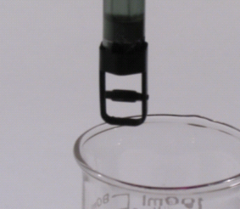
- Place the magnetic stirrer on the base of the ring stand.
- Insert the Conductivity Probe through the large hole in the Drop Counter.
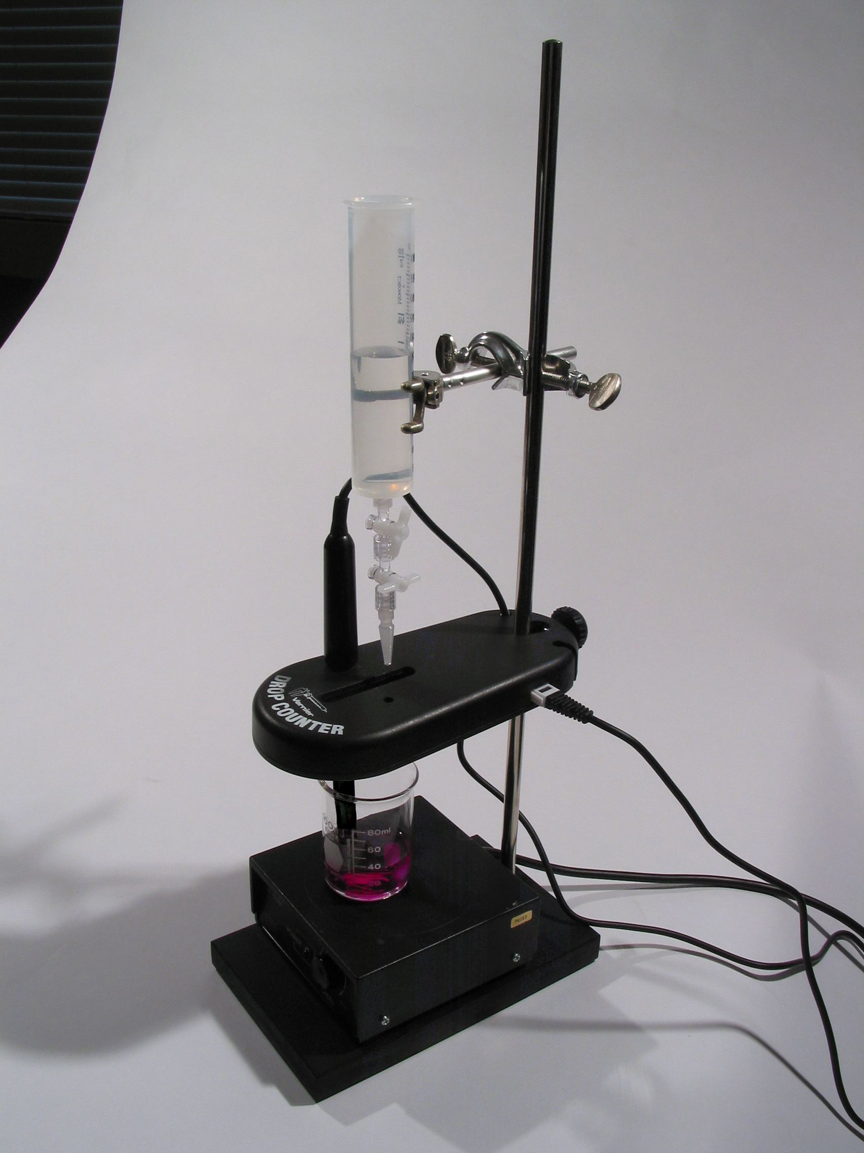
- Attach the Microstirrer to the bottom of the Conductivity Probe, as shown in the small picture. Rotate the paddle wheel of the Microstirrer and make sure that it does not touch the bottom of the Conductivity Probe.
- Adjust the positions of the Drop Counter and reagent reservoir so they are both lined up with the center of the magnetic stirrer.
- Lift up the Conductivity Probe, and slide the beaker containing the Ba(OH)₂ solution onto the magnetic stirrer. Lower the Conductivity Probe into the beaker.
- Adjust the position of the Drop Counter so that the Microstirrer on the Conductivity Probe is just touching the bottom of the beaker.
- Adjust the reagent reservoir so its tip is just above the Drop Counter slot.
9. Turn on the magnetic stirrer so that the Microstirrer is stirring at a fast rate.
10. You are now ready to begin collecting data. Click . No data will be collected until the first drop goes through the Drop Counter slot. Fully open the bottom valve—the top valve should still be adjusted so drops are released at a rate of about 1 drop every 2 seconds. When the first drop passes through the Drop Counter slot, check the data table to see that the first data pair was recorded.
11. Continue watching your graph to see when the conductivity has reached a minimum value—this will be the equivalence point of the reaction. After this minimum conductivity occurs, let the titration proceed until the conductivity reading is about the same as the initial conductivity value, then click . Turn the bottom valve of the reagent reservoir to a closed (horizontal) position.
12. Dispose of the beaker contents as directed by your teacher.
13. Print copies of the table.
14. Print copies of the graph.
PROCESSING THE DATA
1. From the data table and graph that you printed, determine the volume of H₂SO₄ added at the equivalence point. The graph should give you the approximate volume at this point. The precise volume of H₂SO₄ added can be determined by further examination of the data table for the minimum conductivity. Record the volume of H₂SO₄.
2. Calculate moles of H₂SO₄ added at the equivalence point. Use the molarity, M, of the H₂SO₄ and its volume, in L.
3. Calculate the moles of Ba(OH)₂ at the equivalence point. Use your answer in the previous step and the ratio of moles of Ba(OH)₂ and H₂SO₄ in the balanced equation (or use the 1:1 ratio of moles of H⁺ to moles of OH– from the equation).
4. From the moles and volume of Ba(OH)₂, calculate the concentration of Ba(OH)₂, in mol/L.
EQUIVALENCE POINT DETERMINATION: An Alternate Method
An alternate way of determining the precise equivalence point of this titration is to perform two linear regressions on the data. One of these will be on the linear region of data approaching the equivalence point, and the other will be the linear region of data following the equivalence point. The equivalence point volume corresponds to the volume at the intersection of these two lines.
1. Drag your mouse cursor across the linear region of data that precedes the minimum conductivity reading. Click on the Linear Fit button, 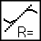.
2. Drag your mouse cursor across the linear region of data that follows minimum conductivity reading. Click on the Linear Fit button, .
3. Choose Interpolate from the Analyze menu. Then move the mouse cursor to the volume reading when both linear fits display the same conductivity reading. This volume reading will correspond to the equivalence point volume for the titration.
DATA TABLE
Molarity of H₂SO₄ | M
Volume of H₂SO₄ | mL = L
Volume of Ba(OH)₂ | mL = L

Moles of H₂SO₄ | mol
Moles of Ba(OH)₂ | mol
Molarity of Ba(OH)₂ | M

