Rate Law Determination of
the Crystal Violet Reaction
In this experiment, you will observe the reaction between crystal violet and sodium hydroxide. One objective is to study the relationship between concentration of crystal violet and the time elapsed during the reaction. The equation for the reaction is shown here:
Figure 1
A simplified (and less intimidating!) version of the equation is:
CV⁺ + OH–(aq) CVOH
(crystal violet) (hydroxide)
The rate law for this reaction is in the form: rate = k[CV⁺]m[OH–]n, where k is the rate constant for the reaction, m is the order with respect to crystal violet (CV⁺), and n is the order with respect to the hydroxide ion. Since the hydroxide ion concentration is more than 5000 times as large as the concentration of crystal violet, [OH–] will not change appreciably during this experiment. Thus, you will find the order with respect to crystal violet (m), but not the order with respect to hydroxide (n).
As the reaction proceeds, a violet-colored reactant will be slowly changing to a colorless product. Using the green (565 nm) light source of a Colorimeter, you will monitor the absorbance of the crystal violet solution with time. We will assume that absorbance is proportional to the concentration of crystal violet (Beer’s law). Absorbance will be used in place of concentration in plotting the following three graphs:
- Absorbance vs. time: A linear plot indicates a zero order reaction (k = –slope).
- ln Absorbance vs. time: A linear plot indicates a first order reaction (k = –slope).
- 1/Absorbance vs. time: A linear plot indicates a second order reaction (k = slope).
Once the order with respect to crystal violet has been determined, you will also be finding the rate constant, k, and the half-life for this reaction.

MATERIALS
TI-83 Plus or TI-84 Plus graphing calculator | 0.10 M NaOH
EasyData application | 2.5 X 10^{–5} M crystal violet solution
data-collection interface | distilled water
Vernier Colorimeter | stirring rod
one plastic cuvette | test tube rack
100 mL beaker
PROCEDURE
1. Obtain and wear goggles.
2. Use a 10 mL graduated cylinder to obtain 10.0 mL of 0.10 M NaOH solution. CAUTION: Sodium hydroxide solution is caustic. Avoid spilling it on your skin or clothing. Use another 10 mL graduated cylinder to obtain 10.0 mL of 2.5 X 10-5 M crystal violet solution. CAUTION: Crystal violet is a biological stain. Avoid spilling it on your skin or clothing.
3. Turn on the calculator. Connect the Colorimeter, data-collection interface, and calculator.
4. Prepare a blank by filling an empty cuvette ¾ full with distilled water. Seal the cuvette with a lid. To correctly use a Colorimeter cuvette, remember:
- All cuvettes should be wiped clean and dry on the outside with a tissue.
- Handle cuvettes only by the top edge of the ribbed sides.
- All solutions should be free of bubbles.
- Always position the cuvette with its reference mark facing toward the white reference mark at the right of the cuvette slot on the Colorimeter.

5. Calibrate the Colorimeter.
- Start the EasyData application, if it is not already running.
- Select  from the Main screen, and then select New to reset the application.
- Place the blank in the cuvette slot of the Colorimeter and close the lid.
- Set the wavelength on the Colorimeter to 565 nm, then calibrate by pressing the CAL button on the Colorimeter.

6. Set up EasyData for data collection.
- Start EasyData if it is not already running.
- Select from the Main screen, and then select New to reset the application.
- Select  from the Main screen, then select Time Graph…
- Select  on the Time Graph Settings screen.
- Enter 4 as the time between samples in seconds and select .
- Enter 45 as the number of samples and select (data collection will last 3 minutes).
- Select  to return to the Main screen.

7. You are now ready to begin monitoring data.
- To initiate the reaction, simultaneously pour the 10 mL portions of crystal violet and sodium hydroxide into a 100 mL beaker and stir the reaction mixture with a stirring rod.
- Empty the water from the cuvette. Rinse the cuvette with ~1 mL of the reaction mixture and then fill it 3/4 full.
- Place the cuvette in the cuvette slot of the Colorimeter and close the lid.
- Monitor the absorbance reading on the main screen of the calculator for about 10 seconds (the absorbance reading should be gradually decreasing), then select  to begin data collection.
- During the 3 minute data collection, observe the solution in the beaker as it continues to react.
- Data collection will end after 3 minutes.
- Discard the contents of the beaker and cuvette as directed by your teacher.
8. Analyze the data graphically to decide if the reaction is zero, first, or second order with respect to crystal violet:
- Zero Order: If the current graph of absorbance vs. time is linear, the reaction is zero order.
- First Order: To see if the reaction is first order, it is necessary to plot a graph of the natural logarithm (ln) of absorbance vs. time. If this plot is linear, the reaction is first order.
- Second Order: To see if the reaction is second order, plot a graph of the reciprocal of absorbance vs. time. If this plot is linear, the reaction is second order.

Follow these directions to create the lists natural log (ln) absorbance in L 3 and 1/absorbance in L 4. To do this using your calculator, it is necessary to create a new data lists based on your original volume data.
- Select  to return to the Main screen.
- Select , then to exit EasyData.
- To view the lists, press 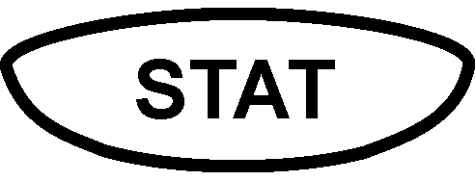 to display the EDIT menu and then  to select Edit.
- To create a list of natural log (ln) of absorbance values in L3, move the cursor up and to the right until the L3 heading is highlighted, then press 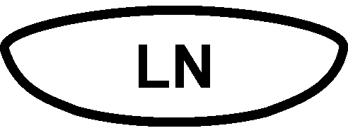 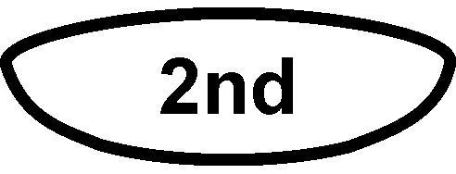 [L2] .
- To create a list of reciprocal of absorbance values in L4, move the cursor up and to the right until the L4 heading is highlighted, then press [L2] 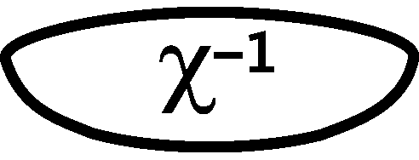 .

9. Follow this procedure to calculate regression statistics and to plot a best-fit regression line on your graph of absorbance, ln absorbance, or reciprocal of absorbance vs. time:
- Restart EasyData.
- Select  from the Main screen to view the graph of absorbance vs. time.
- Select , then Linear Fit. The linear-regression statistics for these two lists you select are displayed for the equation in the form
y = ax + b
where x is time, y is absorbance, ln absorbance or reciprocal absorbance, a is the slope, and b is the y-intercept. Note: For the plot that is linear, record the value of the slope, a, to use in the calculation of the rate constant, k, in Processing the Data.
- To display the linear-regression curve on the graph, select . Examine your graph to see if the relationship is linear.
- (optional) Print a copy of the graph.
- To view a graph of the two other lists, select  and then select L3 vs L1 or L4 vs L1, and repeat Steps 9c–e. Note that L3 is natural log (ln) absorbance, and L4 is reciprocal of absorbance.

Processing the data
1. Was the reaction zero, first, or second order, with respect to the concentration of crystal violet? Explain.
2. Calculate the rate constant, k, using the slope of the linear regression line for your linear curve (k = –slope for zero and first order and k = slope for second order). Be sure to include correct units for the rate constant. Note: This constant is sometimes referred to as the pseudo rate constant, because it does not take into account the effect of the other reactant, OH–.
3. Write the correct rate law expression for the reaction, in terms of crystal violet (omit OH–).
4. Using the printed data table, estimate the half-life of the reaction; select two points, one with an absorbance value that is about half of the other absorbance value. The time it takes the absorbance (or concentration) to be halved is known the half-life for the reaction. (As an alternative, you may choose to calculate the half-life from the rate constant, k, using the appropriate concentration-time formula.)

