Determining the Concentration
of a Solution: Beer’s Law
The primary objective of this experiment is to determine the concentration of an unknown nickel (II) sulfate solution. You will be using the Colorimeter shown in Figure 1. In this device, red light from the LED light source will pass through the solution and strike a photocell. The NiSO₄ solution used in this experiment has a deep green color. A higher concentration of the colored solution absorbs more light (and transmits less) than a solution of lower concentration. The Colorimeter monitors the light received by the photocell as either an absorbance or a percent transmittance value.

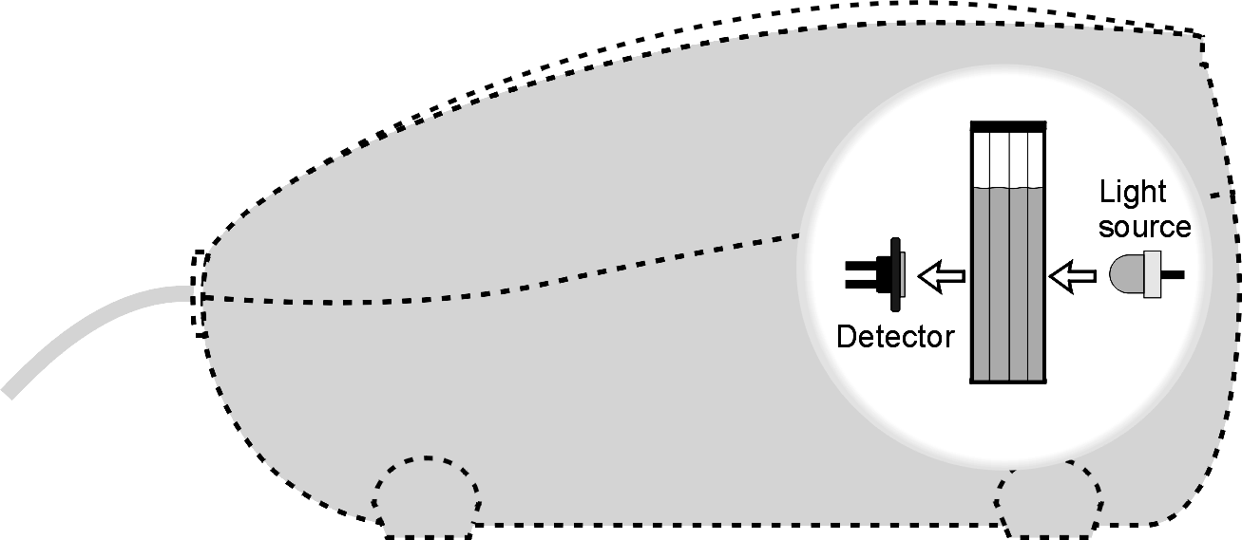

Figure 1

Figure 2
You are to prepare five nickel sulfate solutions of known concentration (standard solutions). Each is transferred to a small, rectangular cuvette that is placed into the Colorimeter. The amount of light that penetrates the solution and strikes the photocell is used to compute the absorbance of each solution. When a graph of absorbance vs. concentration is plotted for the standard solutions, a direct relationship should result, as shown in Figure 2. The direct relationship between absorbance and concentration for a solution is known as Beer’s law.
The concentration of an unknown NiSO₄ solution is then determined by measuring its absorbance with the Colorimeter. By locating the absorbance of the unknown on the vertical axis of the graph, the corresponding concentration can be found on the horizontal axis (follow the arrows in Figure 2). The concentration of the unknown can also be found using the slope of the Beer’s law curve.

MATERIALS
TI-83 Plus or TI-84 Plus graphing calculator | two 10 mL pipets (or graduated cylinders)
EasyData application | two 100 mL beakers
data-collection interface | pipet or pipet bulb
Vernier Colorimeter | distilled water
one cuvette | test tube rack
five 20 X 150 mm test tubes | stirring rod
30 mL of 0.40 M NiSO₄ | tissues (preferably lint-free)
5 mL of NiSO₄ unknown solution
PROCEDURE
1. Obtain and wear goggles! CAUTION: Be careful not to ingest any NiSO4 solution or spill any on your skin. Inform your teacher immediately in the event of an accident.
2. Add about 30 mL of 0.40 M NiSO₄ stock solution to a 100 mL beaker. Add about 30 mL of distilled water to another 100 mL beaker.
3. Label four clean, dry, test tubes 1–4 (the fifth solution is the beaker of 0.40 M NiSO₄). Pipet 2, 4, 6, and 8 mL of 0.40 M NiSO₄ solution into Test Tubes 1–4, respectively. With a second pipet, deliver 8, 6, 4, and 2 mL of distilled water into Test Tubes 1–4, respectively. Thoroughly mix each solution with a stirring rod. Clean and dry the stirring rod between stirrings. Keep the remaining 0.40 M NiSO₄ in the 100 mL beaker to use in the fifth trial. Volumes and concentrations for the trials are summarized below:
Trial  number | 0.40 M NiSO₄  (mL) | Distilled H₂O  (mL) | Concentration  (M)
1 | 2 | 8 | 0.08
2 | 4 | 6 | 0.16
3 | 6 | 4 | 0.24
4 | 8 | 2 | 0.32
5 | ~10 | 0 | 0.40

4. Turn on the calculator. Connect the Colorimeter, data-collection interface, and calculator.
5. Prepare a blank by filling an empty cuvette ¾ full with distilled water. Seal the cuvette with a lid. To correctly use a Colorimeter cuvette, remember:
- All cuvettes should be wiped clean and dry on the outside with a tissue.
- Handle cuvettes only by the top edge of the ribbed sides.
- All solutions should be free of bubbles.
- Always position the cuvette with its reference mark facing toward the white reference mark at the right of the cuvette slot on the Colorimeter.

6. Set up EasyData for data collection and calibrate the Colorimeter.
- Start the EasyData application, if it is not already running.
- Select  from the Main screen, and then select New to reset the application.
- Select  from the Main screen, and then select Events with Entry.
- Place the blank in the cuvette slot of the Colorimeter and close the lid.
- Set the wavelength on the Colorimeter to 635 nm, then calibrate by pressing the CAL button on the Colorimeter.

7. You are now ready to collect absorbance-concentration data for the five standard solutions.
- Select  from the Main screen.
- Empty the water from the cuvette. Using the solution in Test Tube 1, rinse the cuvette twice with ~1 mL amounts and then fill it 3/4 full. Wipe the outside with a tissue, place it in the Colorimeter, and close the lid.
- When the value displayed on the calculator screen has stabilized, select . Enter 0.080 as the concentration in mol/L, then select . The absorbance and concentration values have now been saved for the first solution.
- Discard the cuvette contents as directed by your instructor. Using the solution in Test Tube 2, rinse the cuvette twice with ~1 mL amounts, and then fill it 3/4 full. After closing the lid, wait for the value displayed on the calculator screen to stabilize and select . Enter 0.16 as the concentration in mol/L, and select .
- Repeat the procedure for Test Tube 3 (0.24 M) and Test Tube 4 (0.32M), as well as the stock 0.40 M NiSO₄. Note: Wait until Step 8 to do the unknown.
- Select  to stop data collection. The absorbance and concentration values have now been saved for the standard solutions.
- Examine the data points along the curve on the displayed graph. As you move the cursor right or left, the concentration (X) and absorbance (Y) values of each data point are displayed above the graph. Record the absorbance values in your data table (round to the nearest 0.001).
- Select  to return to the Main screen.

8. Determine the absorbance value of the unknown NiSO₄ solution. To do this:
- Obtain about 5 mL of the unknown NiSO₄ in another clean, dry, test tube. Record the number of the unknown in your data table.
- Rinse the cuvette twice with the unknown solution and fill it about 3/4 full. Wipe the outside of the cuvette, place it into the Colorimeter, and close the lid.
- Monitor the absorbance value displayed on the calculator. When this value has stabilized, record it in your data table (round to the nearest 0.001).
- Dispose of the remaining solution as directed by your instructor.

9. Discard the solutions as directed by your instructor. Proceed directly to Steps 1–2 of Processing the Data.
Processing the data
1. To determine the concentration of the unknown NiSO₄ solution, plot a graph of absorbance vs. concentration with a linear regression curve displayed, then interpolate along the regression line to convert the absorbance value of the unknown to concentration. To do this:
- Select  from the Main screen.
- Select , then Linear Fit. The linear-regression statistics for these two lists are displayed for the equation in the form
y = ax + b
where y is absorbance, x is concentration, a is the slope, and b is the y-intercept. Note: One indicator of the quality of your data is the size of b. It is a very small value if the regression line passes through or near the origin. The correlation coefficient, r, indicates how closely the data points match up with (or fit) the regression line. A value of 1.00 indicates a nearly perfect fit.
- To display the linear-regression curve on the graph of absorbance vs. concentration, select . This graph should indicate a direct relationship between absorbance and concentration, a relationship known as Beer’s law. The regression line should closely fit the five data points and pass through (or near) the origin of the graph.
- To interpolate along the curve, press . A cursor is displayed on the regression line, along with its X and Y coordinates below the graph. Use  or  to move the cursor to an absorbance value (Y value) that is closest to the absorbance reading you obtained in Step 8. The NiSO₄ concentration, in mol/L, will be equal to the corresponding X value. Record this value in your data table.
2. Print a graph of absorbance vs. concentration, with a regression line and interpolated unknown concentration displayed.

DATA and calculations
Trial | Concentration (mol/L) | Absorbance
1 | 0.080
2 | 0.16
3 | 0.24
4 | 0.32
5 | 0.40
6 | Unknown number ____

Concentration of unknown | mol/L

