Acid-Base Titration
A titration is a process used to determine the volume of a solution needed to react with a given amount of another substance. In this experiment, you will titrate hydrochloric acid solution, HCl, with a basic sodium hydroxide solution, NaOH. The concentration of the NaOH solution is given and you will determine the unknown concentration of the HCl. Hydrogen ions from the HCl react with hydroxide ions from the NaOH in a one-to-one ratio to produce water in the overall reaction:
H⁺(aq) + Cl–(aq) + Na⁺(aq) +OH–(aq) H₂O(l) + Na⁺(aq) + Cl–(aq)
When an HCl solution is titrated with an NaOH solution, the pH of the acidic solution is initially low. As base is added, the change in pH is quite gradual until close to the equivalence point, when equimolar amounts of acid and base have been mixed. Near the equivalence point, the pH increases very rapidly, as shown in Figure 1. The change in pH then becomes more gradual again, before leveling off with the addition of excess base.
In this experiment, you will use a pH Sensor to monitor pH as you titrate. The region of most rapid pH change will then be used to determine the equivalence point. The volume of NaOH titrant used at the equivalence point will be used to determine the molarity of the HCl.
Figure 1

MATERIALS
Materials for both Method 1 (buret) and Method 2 (Drop Counter)
LabPro or CBL 2 interface | magnetic stirrer (if available)
TI graphing calculator | stirring bar or Microstirrer (if available)
DataMate program | wash bottle
Vernier pH Sensor | distilled water
HCl solution, unknown concentration | ring stand
~0.1 M NaOH solution | 1 utility clamp
pipet bulb or pump | 250 mL beaker
Materials required only for Method 1 (buret)
50 mL buret | 2nd utility clamp
10 mL pipet | 2nd 250 mL beaker
Materials required only for Method 2 (Drop Counter)
Vernier Drop Counter | 100 mL beaker
60 mL reagent reservoir | 10 mL graduated cylinder
5 mL pipet or graduated 10 mL pipet

CHOOSING A METHOD
Method 1 has the student deliver volumes of NaOH titrant from a buret. After titrant is added, and pH values have stabilized, the student is prompted to enter the buret reading manually and a pH-volume data pair is stored.
Method 2 uses a Vernier Drop Counter to take volume readings. NaOH titrant is delivered drop by drop from the reagent reservoir through the Drop Counter slot. After the drop reacts with the reagent in the beaker, the volume of the drop is calculated, and a pH-volume data pair is stored.
METHOD 1: Measuring Volume Using a Buret
1. Obtain and wear goggles.
2. Use a pipet bulb (or pipet pump) to pipet 10 mL of the HCl solution into a 250-mL beaker. Add 50 mL of distilled water. CAUTION: Handle the hydrochloric acid with care. It can cause painful burns if it comes in contact with the skin.
3. Place the beaker on a magnetic stirrer and add a stirring bar. If no magnetic stirrer is available, you need to stir with a stirring rod during the titration.
Figure 2
4. Plug the pH Sensor into Channel 1 of the LabPro or CBL 2 interface. Use the link cable to connect the TI Graphing Calculator to the interface. Firmly press in the cable ends.
5. Use a utility clamp to suspend a pH Sensor on a ring stand as shown in Figure 2. Position the pH Sensor in the HCl solution and adjust its position so that it is not struck by the stirring bar.
6. Obtain a 50-mL buret and rinse the buret with a few mL of the ~0.1 M NaOH solution. Dispose of the rinse solution as directed by your teacher. Use a utility clamp to attach the buret to the ring stand as shown in Figure 2. Fill the buret a little above the 0.00-mL level of the buret with ~0.1 M NaOH solution. Drain a small amount of NaOH solution so it fills the buret tip and leaves the NaOH at the 0.00-mL level of the buret. Record the precise concentration of the NaOH solution in your data table. CAUTION: Sodium hydroxide solution is caustic. Avoid spilling it on your skin or clothing.
7. Turn on the calculator and start the DATAMATE program. Press to reset the program.
8. Set up the calculator and interface for the pH Sensor.
- Select SETUP from the main screen.
- If CH 1 displays PH, proceed directly to Step 9. If it does not, continue with this step to set up your sensor manually.
- Press to select CH 1.
- Select PH from the SELECT SENSOR menu.

9. Set up the data-collection mode.
- To select MODE, press once and press .
- Select EVENTS WITH ENTRY from the SELECT MODE menu.
- Select OK to return to the main screen.

10. You are now ready to perform the titration. This process goes faster if one person manipulates and reads the buret while another person operates the calculator and enters volumes.
- Select START to begin data collection.
- Before you have added any NaOH solution, press and type in “0” as the buret volume in mL. Press to save the first data pair for this experiment.
- Add the next increment of NaOH titrant (enough to raise the pH about 0.15 units). When the pH stabilizes, press and enter the current buret reading (to the nearest 0.01 mL). You have now saved the second data pair for the experiment.
- Continue adding NaOH solution in increments that raise the pH by about 0.15 units and enter the buret reading after each increment. When a pH value of approximately 3.5 is reached, change to a one-drop increment. Enter a new buret reading after each increment. Note: It is important that all increment volumes in this part of the titration be equal; that is, one-drop increments.
- After a pH value of approximately 10 is reached, again add larger increments that raise the pH by about 0.15 pH units, and enter the buret level after each increment.
- Continue adding NaOH solution until the pH value remains constant.

11. Press when you have finished collecting data.
12. Examine the data on the displayed graph to find the equivalence point—that is the largest increase in pH upon the addition of 1 drop of NaOH solution. As you move the cursor right or left on the displayed graph, the volume (X) and pH (Y) values of each data point are displayed below the graph. Go to the region of the graph with the largest increase in pH. Find the NaOH volume just before this jump. Record this value in the data table. Then record the NaOH volume after the drop producing the largest pH increase was added.
13. (optional) Using Graphical Analysis or Logger Pro 3 software, print a copy of the NaOH volume and pH data for the titration.
14. If time permits, repeat the procedure.
15. Dispose of the beaker contents as directed by your teacher. Rinse the pH Sensor and return it to the pH storage solution.
METHOD 2: Measuring Volume with a Drop Counter
1. Obtain and wear goggles.
2. Connect the pH Sensor to CH 1 of the LabPro or CBL 2 interface. Lower the Drop Counter onto a ring stand and connect its cable to DIG/SONIC 1.
3. Add 40 mL of distilled water to a 100 mL beaker. Use a pipet bulb (or pipet pump) to pipet 5.00 mL of the HCl solution into the 100 mL beaker with distilled water. CAUTION: Handle the hydrochloric acid with care. It can cause painful burns if it comes in contact with the skin.
4. Obtain approximately 40 mL of ~0.1 M NaOH solution in a 250 mL beaker. Record the precise NaOH concentration in your data table. CAUTION: Sodium hydroxide solution is caustic. Avoid spilling it on your skin or clothing.
5. Obtain the plastic 60 mL reagent reservoir. Note: The bottom valve will be used to open or close the reservoir, while the top valve will be used to finely adjust the flow rate. For now, close both valves by turning the handles to a horizontal position.
Rinse it with a few mL of the ~0.1 M NaOH solution. Use a utility clamp to attach the reagent reservoir to the ring stand. Add the remainder of the NaOH solution to the reagent reservoir.
Drain a small amount of NaOH solution into the 250 mL beaker so it fills the reservoir’s tip. To do this, turn both valve handles to the vertical position for a moment, then turn them both back to horizontal.
6. Launch the DataDrop program, then press the Clear key.
7. Set up the calculator and interface for the pH Sensor.
- If CH 1 displays PH, proceed directly to Step 8. If it does not, continue with this step to set up your sensor manually.
- Select SETUP from the main screen.
- Select PH from the SELECT SENSOR menu.
8. There are three different ways to handle the reporting of volume.

- Do not calibrate drop volume In this case, you can skip to Step 9, and begin collecting data.
- Manually enter a drops/mL ratio value If you have done a previous calibration with this particular apparatus, you can choose CALIBRATE DROPS and manually enter the drops/mL ratio. Choose OK and proceed to Step 9.
- Perform an Automatic drops/mL calibration You can use a 10 mL graduated cylinder and perform this calibration using the following procedure:
- Place a 10 mL graduated cylinder below the slot of the Drop Counter.
- Fill the reagent reservoir with titrant.
- Choose CALIBRATE DROPS from the main screen.
- Choose CALIBRATE NOW.
- Open the bottom 2-way (on-off) valve to begin releasing drops from the vessel through the Drop Counter (the top valve finely adjusts the drop rate).
- Continue to release drops until there are between 9 and 10 mL of liquid in the graduated cylinder.
- Close the bottom valve on the vessel to stop the drops.
- Press .
- Type the precise volume of liquid in the graduated cylinder in milliliters and press .
- The number of drops/mL will be displayed. It may be helpful to record the value for that particular reagent reservoir for future titrations.
- Choose OK to return to the main screen.
- Discard the NaOH solution in the graduated cylinder as indicated by your instructor and set the graduated cylinder aside
9. Assemble the apparatus.
- 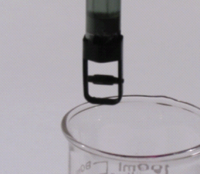Place the magnetic stirrer on the base of the ring stand.
- Insert the pH Sensor through the large hole in the Drop Counter.
- Attach the Microstirrer to the bottom of the pH Sensor, as shown in the small picture. Rotate the paddle wheel of the Microstirrer and make sure that it does not touch the bulb of the pH Sensor.

- 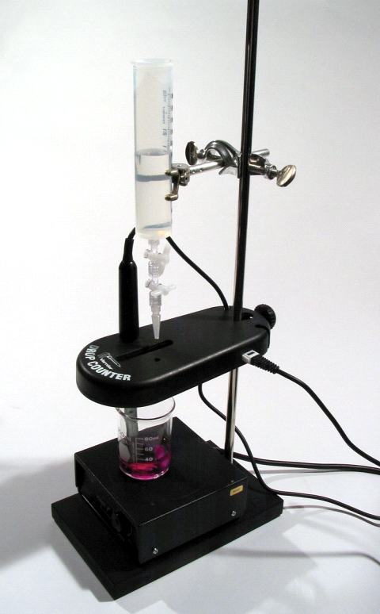Adjust the positions of the Drop Counter and reagent reservoir so they are both lined up with the center of the magnetic stirrer.
- Lift up the pH Sensor, and slide the beaker containing the HCl solution onto the magnetic stirrer. Lower the pH Sensor into the beaker.
- Adjust the position of the Drop Counter so that the Microstirrer on the pH Sensor is just touching the bottom of the beaker.
- Adjust the reagent reservoir so its tip is just above the Drop Counter slot.
10. Turn on the magnetic stirrer so that the Microstirrer is stirring at a fast rate.
11. You are now ready to begin collecting data.
- Choose START. No data will be collected until the first drop goes through the Drop Counter slot.
- Fully open the bottom valve—the top valve should still be adjusted so drops are released at a rate of about 1 drop every 2 seconds. When the first drop passes through the Drop Counter slot, check the data table to see that the first data pair was recorded.
12. Continue watching your graph to see when a large increase in pH takes place—this will be the equivalence point of the reaction. When this jump in pH occurs, let the titration proceed for several more milliliters of titrant, then press . Turn the bottom valve of the reagent reservoir to a closed (horizontal) position.
13. Dispose of the beaker contents as directed by your teacher.
14. (optional) Using Graphical Analysis or Logger Pro 3 software, print a copy of the NaOH volume and pH data for the titration.
15. If time permits, repeat the procedure.
Processing the data
1. Use your printed graph and data table to confirm the volume of NaOH titrant you recorded before and after the largest increase in pH values upon the addition of 1 drop of NaOH solution.
2. Determine the volume of NaOH added at the equivalence point. To do this, add the two NaOH values determined above and divide by two.
3. Calculate the number of moles of NaOH used.
4. See the equation for the neutralization reaction given in the introduction. Determine the number of moles of HCl used.
5. Recall the volume of the unknown HCl solution you used for the titration. Calculate the HCl concentration.

data and calculations
Concentration of NaOH | M | M
NaOH volume added before largest pH increase | mL | mL
NaOH volume added after largest pH increase | mL | mL

Volume of NaOH added at equivalence point | mL | mL
Moles NaOH | mol | mol
Moles HCl | mol | mol
Concentration of HCl | mol/L | mol/L
Average [HCl] | M

