USMLE Step 1 Web Prep — Heart Muscle Mechanics: Part 2
152590 >>> 0:00:00
SLIDE 1 of 5

Cardiac Function Curves | 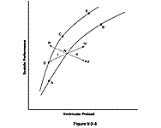

152595 >>> 0:20:35
SLIDE 2 of 5
Afterload
Skeletal muscle: The load on the muscle during contraction.
Left ventricular: The force that the muscle must generate to eject the blood.
Indices of afterload on the left ventricle include:
- Mean aortic pressure
Hypertension - Increased afterload
Hypotension - Decreased afterload
- Peak left ventricular pressure

152600 >>> 0:24:22
SLIDE 3 of 5

Ventricular Volumes  End-Diastolic volume (EDV) – Volume of blood in the ventricle at the end of diastole  End-Systolic Volume (ESV) – Volume of blood in the ventricle at the end of systole  Stroke Volume (SV) – Volume of blood ejected by the ventricle per beat.  SV = EDV - ESV | 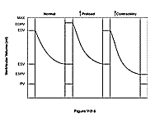

152605 >>> 0:25:41
SLIDE 4 of 5
Control of Heart Rate
- Intrinsic heart rate approximately 110 beats/min.
- Neural influences:
  - Parasympathetic nerves – Right vagus: SA node; left vagus: AV node.
  - Sympathetic nerves – tachycardia; contractility.

152610 >>> 0:26:30
SLIDE 5 of 5

THE BARORECEPTOR REFLEX AND THE CONTROL OF BLOOD PRESSURE  - Baroreceptor reflex - short term regulation of blood pressure  - Renin-angiotensin-aldosterone system – long term regulation of blood pressure  MAP = CO x TPR | 