USMLE Step 1 Web Prep — Overview of Energy Metabolism
115345 >>> 0:00:01
SLIDE 1 of 7

Metabolic Sources of Energy
- In the first stage, metabolic fuels are hydrolyzed to a diverse set of monomeric building blocks (glucose, amino acids, and fatty acids) and absorbed.
- In the second stage, the building blocks are degraded by various pathways in tissues to a common metabolic intermediate, acetyl CoA.
- In stage three, the citric acid (Krebs, or tricarboxylic acid [TCA]) cycle oxidizes acetyl CoA to CO₂. The energy released in this process is primarily conserved by reducing NAD to NADH or FAD to FADH₂.
- The final stage in the extraction of energy from food is oxidative phosphorylation, in which the energy of NADH and FADH₂ is released via the electron transport chain (ETC) and used by an ATP synthetase to produce ATP. This process requires O₂.
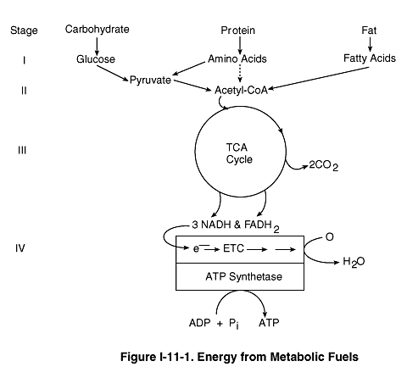

115350 >>> 0:08:02
SLIDE 2 of 7

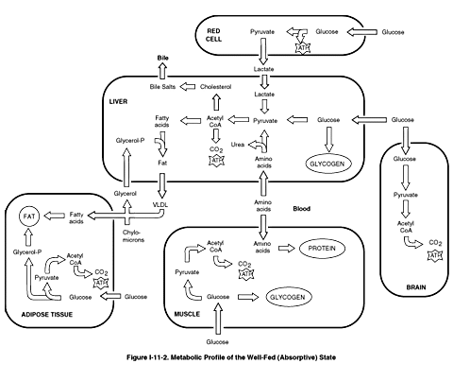

115355 >>> 0:08:46
SLIDE 3 of 7

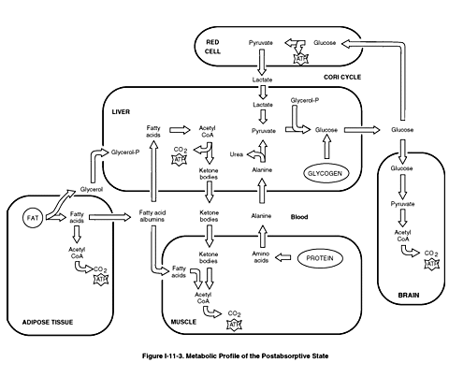

115360 >>> 0:09:25
SLIDE 4 of 7

Well-Fed (Absorptive) State
- Immediately after a meal, the blood glucose level rises and stimulates the release of insulin.
- The three major target tissues for insulin are liver, muscle, and adipose tissue.
- Insulin promotes glucose entry into muscle and adipose tissue.
- Glucose undergoes glycolysis resulting in pyruvate. Pyruvate then is converted to acetyl CoA and enters the Kreb’s cycle, yielding ATP as energy.
- Two tissues, brain and red blood cells, are insensitive to insulin (are insulin independent).
- The brain derives energy from oxidizing glucose to CO₂ and water in both the well-fed and normal fasting states.
- Under all conditions, red blood cells use glucose anaerobically for all their energy needs, since RBCs have no mitochondria.
- With excess ATP, insulin promotes glycogen synthesis in liver and muscle.
- After the glycogen stores are filled, the liver converts excess glucose to fatty acids and triglycerides.

115365 >>> 0:25:29
SLIDE 5 of 7

Postabsorptive State
- Glucagon and epinephrine levels rise during an overnight fast.
- In the liver, glycogen degradation and the release of glucose into the blood are stimulated.
- Hepatic gluconeogenesis is also stimulated by glucagon, but the response is slower than that of glycogenolysis.
- The release of amino acids from skeletal muscle and fatty acids from adipose tissue are both stimulated by glucagon and epinephrine.
- The amino acids and fatty acids are taken up by the liver, where the amino acids provide the carbon skeletons and the oxidation of fatty acids provides the ATP necessary for gluconeogenesis.

115370 >>> 0:29:30
SLIDE 6 of 7

Well-Fed (Absorptive) State
- Immediately after a meal, the blood glucose level rises and stimulates the release of insulin.
- The three major target tissues for insulin are liver, muscle, and adipose tissue.
- Insulin promotes glucose entry into muscle and adipose tissue.
- Glucose undergoes glycolysis resulting in pyruvate. Pyruvate then is converted to acetyl CoA and enters the Kreb’s cycle, yielding ATP as energy.
- Two tissues, brain and red blood cells, are insensitive to insulin (are insulin independent).
- The brain derives energy from oxidizing glucose to CO₂ and water in both the well-fed and normal fasting states.
- Under all conditions, red blood cells use glucose anaerobically for all their energy needs, since RBCs have no mitochondria.
- With excess ATP, insulin promotes glycogen synthesis in liver and muscle.
- After the glycogen stores are filled, the liver converts excess glucose to fatty acids and triglycerides.

115375 >>> 0:33:43
SLIDE 7 of 7

Postabsorptive State
- Glucagon and epinephrine levels rise during an overnight fast.
- In the liver, glycogen degradation and the release of glucose into the blood are stimulated.
- Hepatic gluconeogenesis is also stimulated by glucagon, but the response is slower than that of glycogenolysis.
- The release of amino acids from skeletal muscle and fatty acids from adipose tissue are both stimulated by glucagon and epinephrine.
- The amino acids and fatty acids are taken up by the liver, where the amino acids provide the carbon skeletons and the oxidation of fatty acids provides the ATP necessary for gluconeogenesis.

