USMLE Step 1 Web Prep — The Genetic Code, Mutations, and Translation: Part 3
115300 >>> 0:00:01
SLIDE 1 of 9

Polysomes
- Messenger RNA molecules are very long compared to the size of a ribosome, allowing room for several ribosomes to translate a message at the same time.
- Because ribosomes translate mRNA in the 5' to 3' direction, the ribosome closest to the 3' end has the longest nascent peptide and is the first to has started (closest to finish).
- Polysomes are found free in the cytoplasm or attached to the rough endoplasmic reticulum (RER), depending on the protein being translated.
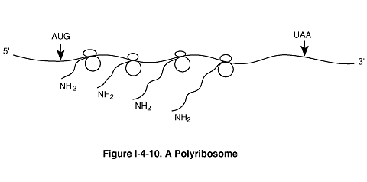

115305 >>> 0:01:52
SLIDE 2 of 9
Inhibitors of Protein Synthesis
- Some well-known inhibitors of prokaryotic translation include streptomycin, erythromycin, tetracycline, and chloramphenicol.
- Inhibitors of eukaryotic translation include cycloheximide and Diphtheria and Pseudomonas toxins.
- Puromycin inhibits both pro- and eukaryotic translation by binding to the A site. Peptidyl transferase attaches the peptide to puromycin, and the peptide with puromycin attached at the C-terminus is released, prematurely terminating chain growth.
- Certain antibiotics (for example, chloramphenicol) inhibit mitochondrial protein synthesis, but not cytoplasmic protein synthesis, because mitochondrial ribosomes are similar to prokaryotic ribosomes.
Amynoglycosides inhibits 30s subunit, prevents initiation of translation (bound to initiation complex at a spot when it goes to P side, and kink to mRNa (distorted))- proteins of bacteria will be aberrant- SE-nephro-(25% renal failure), ototoxicity
Tetracycline- bind to A site of ribosome- prevents elongation – binds to Ca in bones and teeth- reversible discoloration- renal failure ( Fanconi-like syndrome) – doxycycline in prostatitis
50’s subunit inhibitor– chloramphenicol (peptide bond formation via peptydil transferase)- lipid soluble-cross blood- brain barrier- H. influenza meningitis, SE-aplastic anemia, gray-baby syndrome, inhibitor of cytochrome P450
50s –klindamycin (gram+, some anaerobs, bone infection, pseudomembranous colitis), macrolids (immunosuppresed patients HIV(50%) in M. avium comples – inhibit elongation- prevent translocation

115310 >>> 0:08:30
SLIDE 3 of 9
Protein Folding and Subunit Assembly
- As proteins emerge from ribosomes, they fold into three-dimensional conformations that are essential for their subsequent biologic activity. Generally, four levels of protein shape are distinguished:
  - Primary--sequence of amino acids specified in the gene.
  - Secondary--folding of the amino acid chain into an energetically stable structure, either into an alpha-helix, or a beta-pleated-sheet.
  - Tertiary--positioning of the secondary structures in relation to each other to generate higher-order three-dimensional shapes. Tertiary structure also includes the shape of the protein as a whole (globular, fibrous).
  - Quaternary--in proteins such as hemoglobin that have multiple subunits, quaternary structure describes the interactions among subunits; RNA polymerase of bacteria(a, b1, b2,delta)

115315 >>> 0:12:48
SLIDE 4 of 9

N-Terminal Hydrophobic Signal Sequence
- This sequence is found on proteins destined to be secreted (insulin), placed in the cell membrane (Na⁺-K⁺ ATPase), or ultimately directed to the lysosome (sphingomyelinase).
- Translation begins on free cytoplasmic ribosomes, but after translation of the signal sequence, the ribosome is positioned on the ER (now RER) with the help of a signal recognition particle.
- The signal sequence is cleaved off in the ER (signal peptidase) and then the protein passes into the Golgi apparatus for further modification and sorting.
- In transit through the ER and Golgi apparatus, the proteins acquire oligosaccharide side chains attached commonly at serine or threonine residues (O-linked) or at asparagine residues (N-linked).
- N-linked glycosylation requires participation of a special lipid called dolichol phosphate (intermediate of cholesterol metabolism).
5’ of gene(of exon 1) codes N-terrminal signal sequence.- protein remains in cytoplasm if these site is damaged
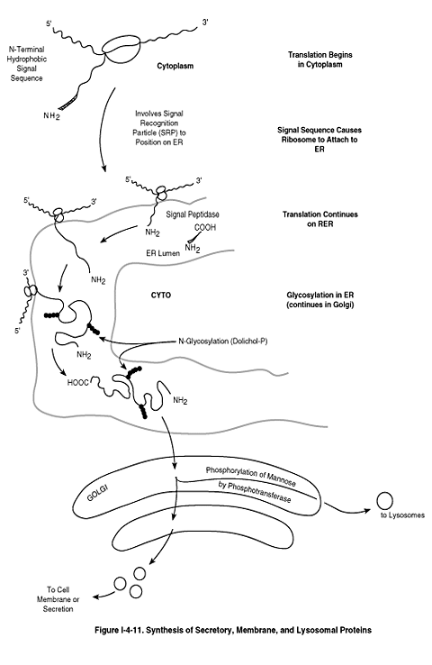

115320 >>> 0:18:10
SLIDE 5 of 9

Lysosomal Enzymes and Phosphorylation of Mannose  - When Lysosomal enzymes arrive in the Golgi apparatus, specific mannose residues in their oligosaccharide chains are phosphorylated by phosphotransferase.  - This phosphorylation is the critical event that removes them from the secretion pathway and directs them to lysosomes.  - Genetic defects affecting this phosphorylation produce I-cell disease in which lysosomal enzymes are released into the extracellular space, and inclusion bodies accumulate in the cell, compromising its function.  - Hydrolytic enzymes will be free and cell lysis | 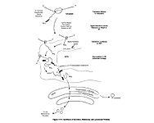

115325 >>> 0:21:26
SLIDE 6 of 9

Co- and Posttranslational Covalent Modifications
- Glycosylation—addition of oligosaccharide as proteins pass through the ER and Golgi apparatus. (α and β- receptors of smooth muscle- ligand recognition)
- Proteolysis—cleavage of peptide bonds to remodel proteins and activate them (activating of prohormones –> proinsulin- C peptide= insulin; all pancreatic peptidase except amylase and lipase are made as propeptide to prevent self-digestion)
- Phosphorylation—addition of phosphate by protein kinases chage acitivty of enzymes (activate/inactivate)
- γ-Carboxylation—produces Ca²⁺ binding sites (additional carboxyl group to glutamate gives negative charge to glutamate-> stimulate Ca binding)- clotting factors II, VII, IX, X that require vit. K are influenced by warfarin (prevents activation of the clotting factors by preventing γ-carboxylation)
- Prenylation—addition of farnesyl or geranylgeranyl lipid groups (terpin) to certain membrane-associated proteins. – ion channel, G-channel

115330 >>> 0:27:01
SLIDE 7 of 9

Posttranslational Modifications of Collagen
- Collagen is an example of a protein that undergoes several important co- and posttranslational modifications.
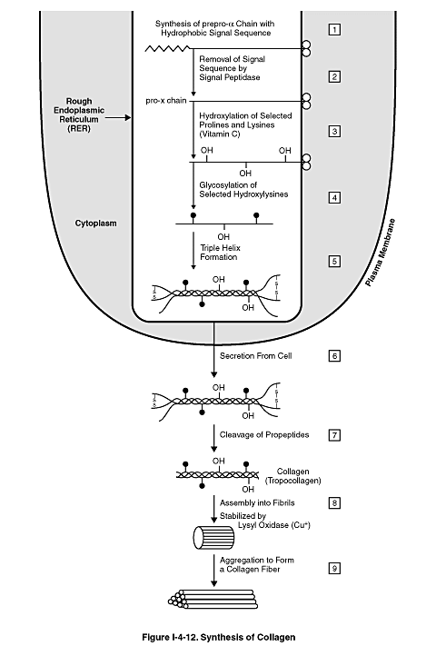

115335 >>> 0:33:46
SLIDE 8 of 9
Table I-4-2. Disorders of Collagen Biosynthesis
Disease | Defect | Major Symptoms
Scurvy | Deficient hydroxylation secondary to ascorbate deficiency (ER enzyme) | Petechiae, ecchymoses  Loose teeth, bleeding gums  Poor wound healing  Poor bone development
Osteogenesis imperfecta | Mutations in collagen genes | Skeletal deformities  Fractures, blue sclera
Ehlers-Danlos syndromes | Mutations in collagen genes and lysine hydroxylase (Eh-Dan IX) gene  Eh-Dan IV- collagen III- for pliable structure- strong and flexible- blood vessels, GI walls | Hyperextensible, fragile skin  Hypermobile joints, dislocations, varicose veins, ecchymoses, arterial, intestinal ruptures
Menkes disease | Deficient cross-linking secondary to functional copper deficiency –lysil oxidase in cytoplasm – (deficit in efflux protein found in Gi protein deficiency- Cu is not absorbed) (also Winkel) | Depigmented (steely) hair-due to secondary tyrosinase deficiency (use Cu)  Arterial tortuosity, aneurism, rupture  Cerebral degeneration  Osteoporosis, anemia

115340 >>> 0:41:07
SLIDE 9 of 9
Table I-4-3. Important Points About the Genetic Code, Mutations, and Translation
 | Prokaryotic | Eukaryotic
Genetic code | Start: AUG (also codes for Met)  Stop: UAG, UGA, UAA  Unambiguous (1 codon = 1 amino acid)  Redundant (1 amino acid >1 codon); often differ at base 3
Mutations | Point mutations: silent, missense, nonsense  Frameshift (delete 1 or 2 nucleotides; not multiple of 3)  Large segment deletion
Mutations |  | Mutation in splice site  Trinucleotide repeat expansion
Amino acid activation | Aminoacyl-tRNA synthetase: two high-energy bonds (ATP) to link amino acid to tRNA
Translation: Initiation | 30S subunit (16sRNA) binds to Shine-Dalgarno sequence on mRNA  fmet-tRNA_{I} binds to P site  GTP required | 40S subunit associates with 5' cap on mRNA  Met-tRNA_{I} binds to P site  GTP required
Translation: Elongation | Charged aminoacyl-tRNA binds to A site (GTP)  Peptide bond forms (two high-energy bond from amino acid activation)  Peptidyl synthase (50S subunit)  Translocation: GTP required | Charged aminoacyl-tRNA binds to A site (GTP)  Peptide bond forms (two high-energy bond from amino acid activation)  Peptidyl synthase (50S subunit)  Translocation: GTP required  eEF-2 inhibited by Diptheria and Pseudomonas toxins
Termination | Release of protein; protein synthesized N to C
Protein targeting |  | Secreted or membrane proteins: N-terminal hydrophobic signal sequence  Lysosomal enzymes: phosphorylation of mannose by phosphotransferase in Golgi apparatus  I-cell disease

